BRIDG Model

http://www.bridgmodel.org
Release 3.0.2 User’s Guide
Biomedical Research Integrated Domain Group (BRIDG)

prepared by

BRIDG Semantic Coordination Committee (SCC)
Becky Angeles (ScenPro/NCI/HL7 RCRIM)
Julie Evans (CDISC/HL7 RCRIM)
Smita Hastak (ScenPro/NCI/HL7 RCRIM)
Lloyd McKenzie (Gordon Point Informatics/NCI/HL7)
Charlie Mead (NCI/HL7)
Steve Sandberg (ScenPro/NCI/HL7 RCRIM)
Wendy Ver Hoef (ScenPro/NCI/HL7 RCRIM)
Mike Woodcock (Mayo/NCI)

31 August 2010



Revision History

Date | Summary of Changes
18 June 2007 | Initial Project Documentation for BRIDG Release 1.0
23 October 2007 | Project Documentation for BRIDG Release 1.1
30 October 2009 | User’s Guide for Release 3.0
2 February 2010 | User’s Guide for Release 3.0.1
31 August 2010 | User's Guide for Release 3.0.2

Table of Contents
Revision History 1
1 Guide to the Reader 5
1.1 Overview 5
2 Executive Summary 7
2.1 BRIDG Project Stakeholders 7
2.2 BRIDG Project Goals 7
2.3 Definition of BRIDG Model Domain of Interest 7
2.4 Scope, Organization, and Content of BRIDG Documentation 8
2.5 BRIDG Model Release Schedule 9
2.6 Release 3.0: The New Structure of BRIDG 9
2.7 Projects Contributing Content to the BRIDG Model 11
2.8 Target Audience of the BRIDG Model 12
2.9 Caveats 13
3 The BRIDG Project and the BRIDG Model 14
3.1 History of the BRIDG Project 14
3.1.1 2003-2004: CDISC and HL7 RCRIM WG 14
3.1.2 2004-2005: The caBIG® (and CDISC) Structured Protocol Representation (caSPR) Teams 16
3.1.3 2005-2006: Maturation of the BRIDG Project 16
3.1.4 2007 - Present: BRIDG Evolution 18
3.2 Governance and Organization of the BRIDG project 18
3.2.1 The BRIDG Board of Directors (BoD) 19
3.2.2 The Semantic Coordination Committee (SCC) 20
3.3 Contributing to the BRIDG Model: How Does a Project Team Get Its Content Into the BRIDG Model? 25
3.4 The BRIDG Model website 26
3.5 The BRIDG Model as a “Standard” – Solicitation of Community Input on the BRIDG Model 26
3.6 Uses of BRIDG 26
3.6.1 Case Study: NCI’s use of the BRIDG Model to facilitate Semantic Interoperability within the caBIG® Cancer Clinical Trials Suite (CCTS) of applications. 26
3.6.2 BRIDG’s Role in CDISC’s SHARE Project 28
4 The BRIDG Model – General Considerations and Representational Conventions 28
4.1 Computable Semantic Interoperability (CSI) 28
4.2 The BRIDG Model: Instance of a Domain Analysis Model 28
4.2.1 The Domain-of-interest of the BRIDG Model 29
4.2.2 The Scope of a DAM 29
4.3 UML: the BRIDG Model’s Representational Language 30
4.4 Disease-Specific Model Strategy 30
4.5 BRIDG Representational Conventions 30
4.5.1 Study Lifecycle and the Grouping of Activities into “Pillars” 30
4.5.2 Identifier Type 31
4.5.3 Constraints 32
4.5.4 Relative Timing of Activities 32
4.5.5 Automated Coding and Modified Text 33
4.5.6 Color Coding of Classes in the UML-based Diagrams 33
4.5.7 The Versioning of Study Protocol 33
5 Model Content 35
5.1 Overview 35
5.2 Canonical Perspective 35
5.2.1 Canonical Perspective to SME Perspective Transformation 36
5.2.2 Canonical Perspective to HL7 Perspective Transformation 36
5.3 Subject Matter Expert Perspective – Sub-Domains 36
5.3.1 Protocol Representation 36
5.3.2 Study Conduct 37
5.3.3 Adverse Event 37
5.3.4 Regulatory 37
5.3.5 Common 37
5.3.6 Analysis and Reporting 37
5.4 HL7 Perspective – RIM-based 38
5.5 Ontological Perspective 40
5.6 Relationship to other DAMs 40
5.7 Source Model Mappings 40
5.8 Views (Diagrams) 41
5.8.1 BRIDG – Start Here: Overview 41
5.8.2 BRIDG Domain Analysis Model: BRIDG Sub-Domain Packages Diagram 41
5.8.3 BRIDG Domain Analysis Model: UML-Based Comprehensive BRIDG Model 41
5.8.4 Sub-Domain Views 41
5.9 Class Diagrams 41
5.10 Instance Diagrams 41
5.11 State Diagrams 41
5.12 Release Package 42
6 Glossary 46
7 Appendix 48
7.1 Abstract and Complex Data Types 48
7.1.1 Temporal Grammar(s): HL7/ISO Data Type TS Data Type 49
7.1.2 Coded Concepts: HL7/ISO Data Type CD Data Type 49
7.1.3 Collections: BAG, SET, and LIST 49
7.2 Instances as “KindOf” vs. “InstanceOf” – holding a place vs. filling it 50
7.3 A Brief Explanation of the concept of “mood” 50
7.4 caBIG®: Using the BRIDG Model 52
7.4.1 caBIG® CTMS WS Silver Compatibility: An Instance of Application Development Processes Using the BRIDG Model 52
7.5 BRIDG and the Four Pillars of Computable Semantic Interoperability 53
7.5.1 CSI Pillar #1: A Common Reference Model 53
7.5.2 CSI Pillar #2: Complex Data Types 54
7.5.3 CSI Pillar #3: Binding to Terminologies 54
7.5.4 CSI Pillar #4: Derivation of Data Interchange Structures from Pillars #1 - #3 54
7.6 The Concepts of Visit and Event 55
7.7 Introduction to Basic UML Class Diagram Concepts and Terms 55
7.7.1 What is UML? 55
7.7.2 What is a class diagram? 56
7.7.3 Attribute names and data types 56
7.7.4 Example of an attribute list of a class from the BRIDG 57
7.7.5 Different types of associations between classes in a UML diagram 58

Guide to the Reader

Overview
The BRIDG User’s Guide consists of seven Sections:

Section 1.0 – Guide to the Reader (the present Section). This Section provides a brief summary of the content of each Section of this document.

Section 2.0 – Executive Summary. This Section contains the following:

- a list of the BRIDG Project’s stakeholder organizations;

- a brief discussion of the overarching goal of the BRIDG Model;
- the scope of the BRIDG Model;
- an outline of the scope, organization, and content of the BRIDG Model User’s Guide;
- an overview of the BRIDG Model release process and schedule;
- content-labeling conventions in the BRIDG Model;
- a list of the projects which have, to date, collectively contributed static or dynamic content to the BRIDG Model;
- a discussion of the intended audience of the BRIDG Model and this associated User’s Guide;
- a list of caveats and/or scope limitations on the overall content of the BRIDG Model User’s Guide.

Section 3.0 – The BRIDG Project. This section contains short discussions on the following topics:

- overview and history of the BRIDG Project;

- organization and function of the two administrative groups that together are responsible for the continued definition, maintenance, and evolution of the BRIDG Model, i.e. the Semantic Coordination Committee (SCC) and the BRIDG Board of Directors (BoD);

- an overview of the process that enables a specific project working in the domain defined by the BRIDG Model to utilize the BRIDG Model and/or contribute to its overall semantic content;

- instructions on how to access the BRIDG website and other resources available to enable interested readers to learn more about BRIDG;

- an explanation of the BRIDG Release Schedule;

- a brief the BRIDG Model version management strategies

- a discussion of the topic of “BRIDG as a standard”;

- an example of how the BRIDG Model is being used to help attain the overall goal of achieving computable semantic interoperability (CSI) within the Clinical Trial Management System Work Space (CTMS WS) of the caBIG® program.

Section 4.0 – The BRIDG Model – General Considerations. This section describes the BRIDG Model from a relatively content-independent perspective, i.e. from the perspective of topics such as the general modeling approaches, representational guidelines, naming conventions, as they are utilized in the BRIDG Model.

Section 5.0 – The BRIDG Model. This section describes the specific content of the current Release of the BRIDG Model including discussions about particular representational choices made by the Semantic Coordination Committee as those choices relate to specific content.

Section 6.0 – Glossary. The Glossary contains a list of definitions of terms that may not be familiar to readers of the BRIDG User’s Guide, the stated definitions reflecting the use of the term in the context of the BRIDG User’s Guide. Throughout the BRIDG User’s Guide, terms which are defined in the Glossary are indicated by being underlined.

Section 7.0 – Appendix. This section contains material that may be of interest to some readers of the BRIDG User’s Guide, but is not a primary part of the BRIDG Model. Examples include a basic UML primer and a more detailed discussion of Abstract/Complex Data Types.

Executive Summary

BRIDG Project Stakeholders
The BRIDG Project is a collaborative effort engaging stakeholders from four organizations:

- Clinical Data Interchange Standards Consortium (CDISC)

- HL7 Regulated Clinical Research Information Management Work Group (HL7 RCRIM WG)

- National Cancer Institute (NCI), including the Cancer Biomedical Informatics Grid (caBIG®)project

- Food and Drug Administration (FDA)

BRIDG Project Goals
The goal of the BRIDG Project is to produce a shared view of the dynamic and static semantics of a common domain-of-interest, specifically the domain of protocol-driven research and its associated regulatory artifacts.
A shared semantic view is essential if the clinical research community, both for itself and also as part of the larger Healthcare and life sciences communities, is to achieve computable semantic interoperability (CSI), i.e. the ability for information systems to exchange at a machine-to-machine level the meaning (rather than simply the structure) of data and/or to effectively combine functionality across machine/system boundaries. Stated another way, in order to realize the various data interchange and application interactions that are known by members of the BRIDG stakeholder organizations to be requirements for CSI, a shared view of dynamic and static semantics must be established.

Through the efforts of the BRIDG Project, this shared view is expressed as a collection of visual diagrams which are, in turn, expressed using the iconography and grammar of the Unified Modeling Language (UML) and the HL7 Reference Information Model (RIM). This set of visual diagrams plus the underlying inter-diagram relationships, definitions, explanations, and examples (instance diagrams which illustrate the semantics of the diagrams in more detail) are collectively referred to as the BRIDG Model. For a short introduction to UML, please see Section 7.7.

Definition of BRIDG Model Domain of Interest
The BRIDG Model is an instance of a construct often referred to as Domain Analysis Model (DAM) or “problem space model.” The term “analysis” refers to the fact that the model is specifically constructed to be implementation-independent, i.e. the semantics of the model are restricted to those that characterize the “problem domain” as described by domain experts. In particular, a DAM specifically excludes semantics that are introduced based on a particular “solution space” that can be built to solve the stated problem. Thus, one or more “solution space models” can be built to support all or part of a single problem space model. The term “domain” indicates that the semantics of the model-in-question are restricted to those that collectively define a clearly bounded domain-of-interest. In the case of the BRIDG Model, the domain-of-interest is formally defined as:

Protocol-driven research and its associated regulatory artifacts,
i.e. the data, organization, resources, rules, and processes involved in the formal assessment of the utility, impact, or other pharmacological, physiological, or psychological effects of a drug, procedure, process, subject characteristic, biologic, cosmetic, food or device on a human, animal, or other subject or substance plus all associated regulatory artifacts required for or derived from this effort, including data specifically associated with post-marketing adverse event reporting.

Scope, Organization, and Content of BRIDG Documentation
As outlined in the Guide to the Reader, the content of the User’s Guide has three main purposes:

- First, to provide a brief historical background and administrative overview of the BRIDG Project, including how the BRIDG Model is maintained and evolved.
- Second, to describe the framework of guidelines and principles that have been used to develop the BRIDG Model, thereby providing those domain experts or technologists interested in reviewing the Model’s content a means for placing their particular perspective in the larger context of the BRIDG Model, as well as to realize that the representational choices made for a given semantic in the BRIDG Model simply represent just that: a representational choice, and that there may be any number of other representation choices at either the analysis or design level of that semantic that could be made.

- Finally, to describe the content of Release 3.0.2 in the context of the two bullets above.

Each release of the BRIDG Model includes the following artifacts:

- The complete BRIDG Model as an EA file.

- This User’s Guide document, which is relatively stable and changes little from release to release.

- A Release Notes document, which is a short document that describes the release.

BRIDG Model Release Schedule
The BRIDG Semantic Coordination Committee sets the release schedule for BRIDG. The schedule depends on the need for publishing new content as prioritized by the BRIDG Board of Directors and the needs of BRIDG users. The SCC expects that there will be at least one but not more than two releases per year.

Release 3.0: The New Structure of BRIDG
The releases of the BRIDG Model 2.0, 2.1, and 2.2 marked an important transition point in the evolution of the BRIDG Model. Since the publication of BRIDG Release 1.0, the BRIDG Semantic Coordination Committee (SCC) has added considerable new content to the model such as Adverse Events and components of Protocol Representation. In addition, the model is increasingly being used to drive application and interchange specifications by the four stakeholders of the BRIDG Project. Also, more organizations and project teams have gotten interested in the relevance of the shared semantics represented in the BRIDG Model. All members of the BRIDG community benefit from this increase in both the ‘breadth’ (content) and ‘depth’ (application/implementation of BRIDG semantics) of the BRIDG Model.

However, this increase in the breadth and depth of the BRIDG Model has also resulted in a model that is increasingly difficult for domain experts to understand as a result of the attempts of the SCC to represent as much sub-domain-specific verbiage as possible while still maintaining underlying semantic consistency, a balancing act that has been accomplished through the use of the BRIDG ‘pillars’ (a pillar is a temporal stage of study activities – see Section 4.5.1.1 for more detail) and multiple UML stereotypes which also makes it more difficult to non-ambiguously map to the HL7 RIM, a primary requirement of the BRIDG Model.

As a result, the SCC and the BRIDG Board of Directors have formulated a strategy to manage this increase in complexity. The solution involves a multi-perspective approach to modeling the static semantics of protocol-driven research. Each perspective tailors the representation of the semantics to a different audience. Section 5.1 below provides a full description of this new approach.

Conventions for Representing Static and Dynamic Content in the BRIDG Model

A domain analysis model (DAM) has two major types of components: static and dynamic. The static components include the class diagrams and instance diagrams which describe the concepts, attributes, and relationships of the domain-of-interest. The dynamic components include the storyboards, activity diagrams, state diagrams, sequence diagrams, etc. that define the various processes and dynamic behavior of the domain. The BRIDG Model is primarily composed of static components, but does contain some dynamic components, primarily state transition diagrams.

The content of each BRIDG release will include representations of the static semantics from the various projects within the BRIDG Project’s stakeholder organizations whose content has been harmonized into the BRIDG Model since that last release. The current plan for representation of the dynamic content is to reference it in the NCI’s Biomedical Research Business Architecture Model (BAM) and work with NCI to harmonize any new dynamic semantics we get with that model. Since this work is just beginning, the plans are conceptual. However, the BRIDG and BAM will most likely not be on the same release schedule. For more information on the BAM and related work, please see:

National Cancer Institute, caBIG® Knowledge Center, Biomedical Research Business Architecture Model:
- Main Project Page: https://cabig-kc.nci.nih.gov/CTMS/KC/index.php/BAM
- BAM Use Cases:
  - https://cabig-kc.nci.nih.gov/CTMS/KC/index.php/Biomedical_Research_Business_Architecture_Modeling

National Cancer Institute, caBIG® Knowledge Center, Interoperability Scenarios:
- https://cabig-kc.nci.nih.gov/CTMS/KC/index.php/CTMS/CCTS_Interoperability_Scenarios_-_Draft

Projects Contributing Content to the BRIDG Model
The BRIDG static content, by release, is outlined in Figure 2 below.

Release | Project | Stakeholder
R1.0 | Regulated Product Submission (RPS) | FDA/HL7 RCRIM
R1.0 | Patient Study Calendar (PSC) | NCI
R1.0 | Clinical Trial Object Model (CTOM) | NCI
R1.0 | caXchange/LabHub | NCI/HL7RCRIM TC/CDISC
R1.1 | Study Data Tabulation Model (SDTM) | CDISC
R1.1 | Trial Design Model | CDISC
R2.0 | Adverse Events | CDISC, NCI, NIH, US Federal Gov’t, FDA
R2.0 | Player / Scoper for Person and Org | NCI, CDISC
R2.0 | Patient Registry (C3PR) | NCI
R2.1 | Clinical Trial Registry (COPPA, ct.gov, WHO, PRV1.0) | CDISC, NCI
R2.1 | Protocol Abstraction (COPPA – Correlations, Organizations, People and Protocol Abstraction) | NCI
R2.2 | CDISC HL7 Message Study Design (partial) | FDA
R2.2 | CDISC HL7 Message Study Participation | FDA
R3.0 | (Architecture Redesign only)
R3.0.1 | Clinical Trials Registration and Results | HL7 RCRIM
R3.0.2 | caBIG® Central Clinical. Participant Registry (C3PR) | NCI
R3.0.2 | Cancer Adverse Event Reporting System (caAERS) | NCI
R3.0.2 | Patient Study Calendar (PSC) | NCI
R3.0.2 | LabViewer | NCI

Figure 2: Semantic Content of BRIDG by Project and BRIDG Version

Target Audience of the BRIDG Model
The target audience for the BRIDG User’s Guide is, first and foremost, anyone with an interest in learning more about the BRIDG Project in general. In particular, the BRIDG Semantic Coordination Committee (SCC), the authors of this document, expects that the content of the User’s Guide will be of use to:

- domain experts working within the domain scoped by the BRIDG Model;
- analysts, architects, and developers working on defining specific data interchange semantics (e.g., message specifications) or application APIs; and

- terminologists / ontologists interested in augmenting current work involving building ontologies in the BRIDG Model domain-of-interest.

The BRIDG Model is represented using the Unified Modeling Language (UML). However, the model uses only the most obvious and easily understandable constructs of UML and, as a result, the SCC believes that the model, in combination with the content of the User’s Guide, should be readily understandable by anyone with experience and expertise in the BRIDG domain-of-interest. The SCC believes that instance diagrams will aid those domain experts with no prior UML experience in reading, understanding, and validating, the content of the BRIDG Model, thereby adding the essential element of vetting by the larger community that is essential to the relevance, and therefore the success, of the BRIDG Project.

The latter point, large-scale validation/vetting of the content of the BRIDG Model – is of particular importance, since the overarching motivation of the BRIDG Project is to present to the clinical- and pre-clinical-trial community a valid representation of the shared meaning of various concepts, relationships, and processes that collectively define the domain of “protocol-driven research and its’ associated regulatory artifacts.’ In the end, the value of the BRIDG Project and the BRIDG Model produced by that Project are directly related to the degree to which that representation is both valid and relevant to the community. If the BRIDG Model provides a correct and complete view of shared meanings (semantics) of the domain-of-interest in a form that is both understandable to domain experts and robust enough to be utilized by various technology teams charged with building solutions required by those domain experts, the BRIDG Project will be a success. It is towards that goal that all those involved in the BRIDG Project are continually striving.

It should be noted that the ‘correctness’ and ‘completeness’ of the view of the BRIDG Domain’s shared semantics as represented in the BRIDG Model is exactly that: a representation. There are certainly other representations. The SCC’s goal is to produce a single representation that is of some use to all of the BRIDG Model’s stakeholders. Individual groups of stakeholders with particular, focused interests in the BRIDG Model’s domain-of-interest may find alternative representations more useful for their specific purposes and/or implementations. The critical success metric in these situations is whether or not the shared semantics of any alternative representation can be completely and unambiguously mapped to the BRIDG Model.

Caveats
It is not the purpose of the User’s Guide to give detailed instructions as to how a given application development or message specification team can contribute to and/or work with the BRIDG Model. A variety of materials on this topic can be found within the four stakeholder organizations various resource centers, in particular the NCI’s Clinical Trial Management System Workspace application development processes and certification framework, and the HL7 Development Framework (HDF), particularly as it is being utilized by the Regulated Clinical Information Management (RCRIM) Work Group.

Information about the NCI’s Clinical Trial Management System Workspace can be found at https://cabig.nci.nih.gov/workspaces/CTMS/. Information about the HL7 Development Framework can be found at www.hl7.org in the ballot under Background Documents, Methodology.

The BRIDG Project and the BRIDG Model
The BRIDG Project is a collaborative effort engaging stakeholders from the Clinical Data Interchange Standards Consortium (CDISC), the HL7 Regulated Clinical Research Information Management Work Group (RCRIM WG), the National Cancer Institute (NCI) and its Cancer Biomedical Informatics Grid (caBIG®), and the US Food and Drug Administration (FDA). The goal of the BRIDG Project is to develop a shared view of the data, relationships, and processes which collectively define the domain of “protocol-driven research and its associated regulatory artifacts.” The formal definition of the domain can be found in section 2.3.

A shared view of the various data structures and processes that define the BRIDG Model’s domain-of-interest is essential in achieving the larger goal of semantic interoperability (SI) both among people (human semantic interoperability (HSI)) and systems (computable semantic interoperability (CSI)). Through the explicit definitions of shared semantics, either HSI or CSI (depending on the desired goal in a particular context) is possible both within the BRIDG domain-of-interest and between the BRIDG domain and other ‘intersecting’ domains (e.g. Public Health, Healthcare, etc.).

The BRIDG Project is focused on producing the requisite view of shared semantics as a series of graphical “views” expressed in the Unified Modeling Language (UML). Collectively, these views, both dynamic and static, form the BRIDG Model. In particular, the goal of defining and representing the shared semantics (aka “meaning”) of the BRIDG Model’s domain-of-interest means that the primary focus of the BRIDG Project is the gathering and documenting of the various business processes (dynamic semantics), data structures (static semantics), and relationships (static and dynamic semantics) that collectively are required to support HSI and/or CSI. Although the BRIDG Model itself is the primary artifact that is being incrementally assembled by the BRIDG Project, there are several additional artifacts of interest, e.g. BRIDG mapping spreadsheet, and associated educational materials, which describe in some detail various aspects of how a specific project team can utilize the BRIDG Model in its efforts to build message structures and/or applications that support SI at either the HSI or CSI level (the latter, of course, being at least an order-of-magnitude more difficult than the former). Details of these various artifacts are available within this User’s Guide or at www.bridgmodel.org .

History of the BRIDG Project

2003-2004: CDISC and HL7 RCRIM WG
The idea of building a Domain Analysis Model (DAM) which documented the shared semantics of the protocol-driven-research domain began with a September, 2003 dialogue between the CDISC Board of Directors and one of the authors of the BRIDG User’s Guide (Charlie Mead, then a member of the HL7 BoD). The dialogue was, in turn, in response to a request from CDISC leadership to HL7 leadership that the two organizations renew a then 2-year-old Memorandum of Understanding (MoU) to work collaboratively on data exchange standards in domains deemed to be of interest to both organizations. In the context of the renewal of the MoU, CDISC requested HL7 provide an educational session for the CDISC BoD that would provide them with a better understanding of HL7’s model-based approach to message specification, a process that CDISC had attempted to embrace in the context of the HL7 RCRIM Work Group with somewhat limited success.

Figure 3 shows an overview of the motivation for initiating the modeling efforts as the concept was presented to the CDISC BoD in January, 2004.

CDISC XML
(e.g., Operational Data Model (ODM))
HL7 XML
(e.g. Periodic Reporting of CT Lab Results)
CDISC Implementation Specification
HL7 Implementation Specification
HL7 RIM → RCRIM DMIM
Domain Analysis Model
(BRIDG)
Requirements
Design
Implementation
Implementation-Independent Representation
Design-level Representation of Multiple Domains-of-interest

Figure 3: Motivation for Modeling Implementation-Independent Semantics (presentation to the CDISC Board of Directors, January 2004).

Representation of implementation semantics in a DAM facilitates the mapping of those semantics to more than one implementation model, thereby facilitating interoperability between applications or message specification built from either model. As a DAM, the BRIDG Model originally presented only the implementation-independent semantics of the domain-of-interest, i.e. protocol-driven research. The HL7 Reference Information Model (RIM) and its derived, cross-domain artifacts are, strictly speaking, implementation-independent. However, because of the level of abstraction required to develop cross-domain shared semantics, they are not “domain-friendly” having to rely instead on abstractions that are unfamiliar to domain experts in a specific domain (e.g. the BRIDG domain). Finally, XML (as utilized by either HL7 or CDISC) presents semantics in an implementation-specific manner. Representation of the semantics of a domain-of-interest in a separate model from the design or implementation models of those semantics facilitates automated transformations between the various implementations, e.g. between CDISC XML and HL7 XML. Note that fully automated transformation will not be feasible due to imprecisions in any mapping exercises.

Following a discussion of the benefits, risks, and effort involved in pursuing the path of building a DAM, the CDISC BoD elected to begin funding the development of a CDISC DAM. The process officially started with a scope definition meeting in March, 2004, the resulting DAM ultimately becoming the BRIDG Model approximately one year later. The current scope definition of the BRIDG domain is essentially the same as was defined at this initial meeting, i.e. protocol-driven research plus its associated regulatory artifacts.

2004-2005: The caBIG® (and CDISC) Structured Protocol Representation (caSPR) Teams
In February 2004, NCI began a project to develop a structured model of a clinical trial protocol as part of the caBIG® project, awarding a grant to the University of Pittsburgh Medical Center (UPMC) to form the Cancer Structured Protocol Representation (caSPR) Team to focus on identifying a set of data elements suitable for a computational representation of structured protocols. Rather than create “yet another standard,” the caSPR Team began to seek out other groups interested in standardizing the exchange of information related to clinical trials research with whom they might collaborate. The search naturally led to interactions with representatives from both CDISC and the HL7 RCRIM WG. An outgrowth of this collaboration was the inclusion of the caSPR Team – and thus the NCI and caBIG® – in the building of the still-to-be-named “CDISC Domain Analysis Model project.” The first joint modeling sessions involving both members of the CDISC DAM team and the caSPR team were held in the late fall of 2004 (approximately 9 months after the start of the still-to-be-named BRIDG Project), with the meetings continuing over the next 9 months (when the project officially adapted the name ‘BRIDG’ (Biomedical Research Integrated Domain Group), a name chosen more for the meaning of the acronym than the collective meaning of the words behind it). This initial effort, the combination of the work that CDISC had done during the first 9 months of CDISC Domain Analysis Model Project and the first attempts to integrate the work of the caSPR team, resulted in the first Domain Analysis Model of the domain of protocol-driven research, which at that time was referred to by many as the “CDISC Problem Space Model.”

2005-2006: Maturation of the BRIDG Project
The project was officially renamed “BRIDG” in the summer of 2005, in no small part to draw attention to the bridging of the semantic gaps that normally impede SI in general and CSI in particular. In addition, there was considerable motivation to find an as-yet-unused name for the project to prevent the confusing adoption of organization-specific monikers, e.g. CDISC Problem Space Model, HL7 RCRIM Domain Analysis Model, NCI caSPR Model. The acronym “BRIDG”, which, as mentioned above, technically stands for “Biomedical Research Integrated Domain Group”, was chosen to reflect the project’s contribution to building both a variety of different “bridges” between the various stakeholder organizations.

With the inclusion of multiple stakeholders, it became apparent that a more formal organizational governance structure must be defined and put in place if the effort was going to succeed in the long-term. Several of the individuals involved in these initial BRIDG project efforts felt that the project could productively take guidance on consensus building and management of diverse, distributed content from various standards-building organizations such as HL7, W3C, and OASIS. Likewise, experience on the management and evolution of shared content could be drawn from the open-source community in the form of projects such as Linux, Firefox, and Mozilla.

In concert with beginning to articulate the governance of the BRIDG Project, the ever-expanding model was ported from Rational Rose to Enterprise Architect (EA) in the Spring of 2005, in part because of the higher cost without higher (relevant) functionality of the former application, but in larger part to allow the dissemination of the model to a larger community using the free model reader available from Sparx Systems, the makers of EA (www.Sparxsystems.com). In addition, the model itself was moved from residence on a single laptop to a GForge site to take advantage of a number of GForge capabilities such as version control, document management, and bug tracking.

An early version of the BRIDG Model was presented to the HL7 RCRIM WG in late-2005/early-2006 and was subsequently accepted as the single Domain Analysis Model for use by the HL7 RCRIM WG in support of their compliance with the HL7 Development Framework (HDF) and its increased focus on robust representation of implementation-independent requirements. This commitment meant that not only would the HL7 RCRIM WG use the BRIDG Model going forward for all of its message specification efforts, but that it would also commit to reverse engineer all of the implementation-independent semantics from existing RCRIM WG specifications (e.g. Regulated Product Submission, Structured Product Labeling, etc.) into the BRIDG Model, a commitment which is in part evident in the content of the Regulated Product Submission specification in Release 1.0 of the BRIDG Model. At approximately the same time, the CDISC BoD committed to reverse engineering all existing CDISC specifications (e.g. SDTM, ODM, etc.) into the BRIDG Model as well as to adopt a formal technical specification process for future CDISC standards that included the utilization of the BRIDG Model. All four of the BRIDG stakeholder organizations are currently involved with applying “BRIDG in context” in a number of application and/or data interchange projects focused on computable semantic interoperability.

Amidst these activities, it became clear to the stakeholders of the project that additional strategic oversight was needed within the BRIDG Project. As a result, the BRIDG Board of Directors (BoD) was created in August 2005 with representation from each of the four BRIDG Project stakeholder organizations, i.e. HL7, NCI, CDISC, and the FDA. The BRIDG BoD was charged with identifying, securing, and allocating resources to support the modeling effort, establishing priorities for modeling and harmonization efforts, and managing the vetting and review of the evolving model within their stakeholder organizations.

Similar to other open source or standards development organizations as mentioned above, it was also decided that a “Technical Harmonization Committee” (THC) (now called the “Semantic Coordination Committee” (SCC)) needed to be established to manage the operational details of the model construction, harmonization, maintenance, and dissemination. The SCC was tasked with defining and executing the harmonization activities that would result in the representation of project-specific semantics in the larger context of the complete BRIDG Model, i.e. in assembling the various building blocks of the BRIDG Model into a coherent form as they were incrementally presented over time by various stakeholder project teams. The SCC’s responsibilities were defined/restricted to making representational rather than semantic changes in the overall BRIDG Model, as well as to ensure that ambiguous semantics across the various projects contributing to the BRIDG Model were effectively normalized (different terms for the same concept mapped to that concept) or harmonized (same term for different concepts disambiguated through the creation of an appropriate number of newly-named concepts). Like the BRIDG BoD, the SCC has representatives from the four stakeholder organizations with specific modeling and/or associated domain-centric informatics skills. Both the SCC and the BRIDG BoD are discussed in more detail below.

2007 - Present: BRIDG Evolution
As BRIDG became more visible in the community, the BRIDG SCC started hearing feedback from both domain experts and technologists. Many domain experts said that the model was too large, too technical, and did not represent their semantics in language they could understand. The technologists said that the model was not clear enough to map cleanly to downstream models (e.g., design models, implementation models, etc.). As a result, the BRIDG BoD and SCC designed a BRIDG solution that would present each audience of BRIDG with its own perspective.
The BRIDG Model uses a multi-perspective approach to modeling the static semantics of protocol-driven research. Each perspective tailors the representation of the semantics to a different audience. Section 5.1 below contains a full description of this new approach.

In addition, the BRIDG BoD decided in late 2008 to move BRIDG forward as an international standard. See the section below for more on this topic.

Governance and Organization of the BRIDG project
The term “BRIDG Project” (or sometimes simply “BRIDG”) is used to refer to the 3-level UML-based and RIM-based model whose semantics are collectively defined by its various contributors, as well as to the organizational governance and model management, maintenance, and evolution processes defined and executed by various members of the four BRIDG stakeholder organizations. From a governance perspective, there are two groups which operate in the overarching context of the BRIDG Project to oversee the ongoing management, maintenance, support, and evolution of the BRIDG Model: the BRIDG Board of Directors (BRIDG BoD), and the Semantic Coordination Committee (SCC). Following is a brief description of each group’s organization and responsibilities in the context of the overall BRIDG Project.

The BRIDG Board of Directors (BoD)
As mentioned above, the scope, content, organization, and processes of the BRIDG Project are currently defined and supported by four stakeholder organizations: HL7 RCRIM WG, NCI and NCI caBIG®, CDISC, and FDA. The BRIDG BoD was established to provide the four stakeholder organizations with a semi-formal mechanism to direct and monitor the content, management, maintenance, support, and evolution of the BRIDG Model. As stated in the BRIDG BoD charter, the BRIDG BoD consists of appointed and elected members. Each founding stakeholder appoints one member who serves at the discretion of that stakeholder. The elected members are chosen from nominees during the annual election. The number elected, up to a total of eleven members including the appointed members, is at the discretion of the BoD. The BRIDG BoD meets monthly, and is charged with both the general governance of the BRIDG Project, including but not limited to the prioritization and scheduling of content submitted to the SCC for inclusion in the BRIDG Model. In establishing priorities and schedules for harmonization of specific content, the BRIDG BoD strives to maintain an overall balance of perspective in the BRIDG Model, ideally allowing no single stakeholder organization or project perspective to dominate the harmonization schedule, and therefore the BRIDG Model’s content, to the exclusion of the others. Operationally, harmonization priority decisions are made based on consideration of a number of factors including stakeholder balance, overall semantic content balance of the BRIDG Model, state of the project’s “harmonizable artifacts” and an overview of the entire project execution space to make sure complimentary or possibly redundant project content is scheduled concurrently or sequentially whenever possible.

In addition to prioritizing project harmonization schedules, the BRIDG BoD is also available to solve any stakeholder-to-stakeholder issues that may arise, provide a forum for stakeholders to discuss ongoing funding or other support-related issues, as well as to serve as the public face of the BRIDG project.

It should be noted that the BRIDG BoD has defined four collections of tasks that are required for the ongoing management, maintenance, and evolution of the BRIDG Model. The BRIDG BoD monitors resource allocation in each of these areas and targets funding and resource assignments to the BRIDG Project so as to ensure that critical activities in each of the task sets are being appropriately resourced and supported. At present, there are NCI-funded and CDISC-supported resources in each of the four task sets. The four task sets are:

- Infrastructure management – the design and maintenance of the BRIDG web site as well as the necessary infrastructure (GForge) support. These tasks are currently executed by NCI infrastructure personnel.

- Model Maintenance – the updating, formatting, and packaging of the various BRIDG Model elements including views, instance diagrams, definitions, etc. These tasks are currently done by an NCI-funded contractor.

- Education and Training – the generation of appropriate education and training materials about the BRIDG Model including how to work with the BRIDG Model in a particular project setting. These tasks are currently executed by funded or volunteer resources from each of the four stakeholder organizations on an as-needed basis.

- Model Harmonization – the tasks that are the responsibility of the Semantic Coordination Committee which is currently staffed by NCI-funded and CDISC-supported resources.

The Semantic Coordination Committee (SCC)
Although the BRIDG BoD defines the overall prioritization and scheduling decisions as to which content will be moved into the BRIDG Model when, the actual process of representing the semantic content from a given project in the BRIDG Model, i.e. the specific decisions regarding how a given project’s static or dynamic content are represented in the BRIDG Model as a whole, are the responsibility of the SCC (which used to be called the Technical Harmonization Committee (THC)). Specifically, each project brings to a scheduled SCC meeting its harmonizable artifacts, i.e. UML Class and Instance Diagrams documenting the project’s static content (as well as a Mapping Document which lists the project team’s working assumptions as to how the project’s static semantics can be mapped to the current BRIDG Model static content), UML Activity, State, or Sequence Diagrams documenting the project’s dynamic content, and a list of well-defined concepts, attributes, and/or relationships which are present in the project but absent in the current version of the BRIDG Model. The project’s collective (static) content, i.e. the sum of the static harmonization artifacts enumerated above, is then analyzed by the SCC in continuous dialogue with project team members to arrive at a consensus and shared understanding of the chosen representation of the project team’s semantics in the BRIDG Model. The process is collectively referred to as ‘harmonization.’ Interested readers can refer to a more detailed discussion in Section 3.2.2.1 of the differences between Normalization, Harmonization, and Localization.

The SCC also has the ongoing responsibility of ensuring that the semantics which are represented in the BRIDG Model are, in fact, mappable to the HL7 RIM. This mapping is now represented in an HL7 RIM-based perspective of the model. This commitment is part of the overarching commitment to ensure that CDISC and HL7 implementations of BRIDG semantics are, in fact, interoperable. See Section 5 for more details about the RIM-based layer.

Members of the SCC have experience and expertise in clinical trial content and process, standards development, and knowledge acquisition and representation (“modeling”). The SCC meets monthly for several days to work on the harmonization into the BRIDG Model of static and/or dynamic content, i.e. the “BRIDG Harmonizable Artifacts,” from one or more projects which have been previously scheduled based on BRIDG BoD priorities, as well as to prepare the next version of the BRIDG Model for its next scheduled release.

The BRIDG BoD and SCC are working to improve the speed at which semantics are harmonized into BRIDG. One solution that will be implemented toward this goal is to require standardized, harmonizable artifacts from project teams wishing to harmonize with BRIDG. Another solution to be implemented is to involve a member of the BRIDG SCC at the beginning of the project so that the project DAM can be built in a way that enables harmonization. Harmonizable static artifacts include fully documented class diagrams (and instance diagrams as necessary); harmonizable dynamic artifacts include fully documented state diagrams. Full documentation includes definitions for classes, attributes, and associations; data types for each attribute and cardinality for each association. Also, a Style Guide is available for projects to use to build their model so that harmonization is easier (published with BRIDG release 3.0.1). Experience has shown the wisdom of the SCC actively working with a given project team over the lifecycle of the project and prior to the team’s formal submission of its artifacts to the SCC to ensure that the project team is creating analysis level artifacts suitable for BRIDG harmonization, as well as to ensure that they are applying good UML modeling and documentation practices to their analysis model artifacts. A diagram showing the basic flow of the process as it is being adopted within the NCI’s caBIG® is shown below in Figure 4. The document that contains this diagram with more detail can be found at
http://gforge.nci.nih.gov/svnroot/candc/trunk/documents/governance/.

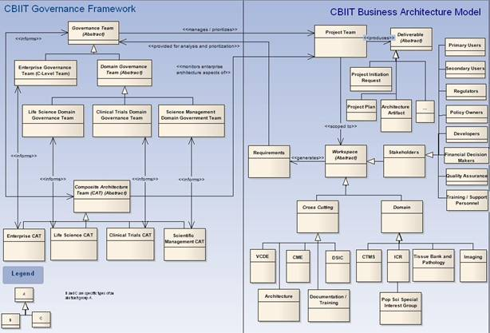

Figure 4: NCI’s CBIIT Governance Framework

A graphical representation of the core components of Center for Biomedical Informatics and Information Technology (CBIIT) governance framework (GF) is shown in Figure 4. The diagram shows both the relevant structural components of the CBIIT Business Architecture on the right half of the figure and the relevant structural components of the CBIIT GF on the left half of the figure. The figure shows how stakeholders, organized into Workspaces, generate requirements which are passed to Governance Teams (GT) – the type of requirement determining the Governance Team to which the specific requirement is given. The GT’s are responsible for determining whether a formal Project Team should be created, often in consultation with the appropriate Composite Architecture Team that assess the proposed project from the technical perspective of the CBIIT Enterprise Architecture.

As mentioned above, when a project team comes to a SCC meeting for harmonization of its content, they are required to bring a “Mapping Document” (currently produced as an Excel spreadsheet) which specifies how the project team believes that each of the elements in their static model maps to the current comprehensive UML-based part of the BRIDG Model. The Mapping Document facilitates the team-SCC harmonization discussions by decoupling the potentially different representational choices made for the same semantics between the two teams. The Mapping Document is also used as a working reference during the SCC meeting to facilitate BRIDG Model representational choices. Over the course of a single multi-day harmonization meeting, it is not uncommon for the BRIDG Model to change both its structure and content as new concepts are included, existing concepts are disambiguated based on the submitting team’s additional perspectives, etc. Over time as more projects are harmonized into the BRIDG Model, the SCC expects that the magnitude of changes to the BRIDG Model will be relatively small, as has been the case with the HL7 Reference Information Model as it matured and stabilized.

The size of the SCC has been kept small to ensure its effectiveness when making representational choices regarding BRIDG Model content. The SCC assumes that the larger community has participated in vetting the various harmonizable artifacts that are presented to the SCC and/or that the community will respond to the various published Releases of the BRIDG Model with appropriate feedback which will, in turn, drive the content of future BRIDG releases. The BRIDG Model only succeeds if the community interested in its semantics utilizes it as a DAM and informs the SCC of its errors, errors which the SCC is committed to promptly addressing in future releases. Project teams define domain semantics; the SCC makes representational choices about these semantics; the community validates both that the semantics were initially stated correctly and completely and that the SCC represented those semantics correctly and completely (realizing that there may be more than one valid representation of a given semantic.)
Over the course of the BRIDG Model’s existence, a number of projects had portions of their content harmonized into various evolving versions of the BRIDG Model. The National Cancer Institute’s caBIG® program has standardized on the BRIDG Model for all applications developed within the Clinical Trial Management System (CTMS) Work Space. In particular, this means that: a) all classes and attributes in the static BRIDG Model are registered in the NCI cancer Data Standards Repository (caDSR) / Enterprise Vocabulary Services (EVS) semantic infrastructure that forms the semantic backbone of the CTMS; and b) all applications and services must build their analysis models based on the BRIDG Model. Additionally, the NCI used common semantics from BRIDG when building its Life Sciences Domain Analysis Model (LSDAM). The Clinical Trials Registry Program (CTRP) at the NCI also used a BRIDG-based model underlying the application. The NCI’s standardized case report forms (CRFs) are also being harmonized with the BRIDG Model. In combination with the reverse engineering of the CDISC and HL7 RCRIM specifications in the BRIDG Model, this effort marks the movement of the BRIDG Project and its associated model “from pilot to enterprise.” It should be noted that although each of the various efforts to add semantics to the BRIDG Model has resulted in clearer definitions and representations of the semantics represented in the model, the definition/boundary of the BRIDG Model has not changed from its original definition (see section 2.3).

Differences in Meaning vs. Differences in Representation: Normalization, Harmonization, Localization and a Note on the Challenges of building a Domain Analysis Model
The process of building a DAM in a domain-of-interest is a process of knowledge extraction, and of establishing common, non-ambiguous knowledge representations across and among various stakeholder groups. The term “harmonization” was taken from the HL7 V3 framework, where it is used to refer to the process whereby multiple perspectives on a given problem are presented to an informed, neutral group who must decide if the various perspectives represent the same or different semantic content, i.e. the process of harmonization is focused on distinguishing true differences in meaning from differences of representation or synonomy, an exercise that is, at times, straightforward, while at other times quite complicated, multi-factorial, and time-consuming. When a difference in meaning, naming (i.e. an instance of synonomy) or representation (synonomy could be considered a trivial case of a representational difference but as used here, the notion of representational differences refers to multi-factorial differences between two structures which have the same meaning/semantics but different structure/syntax) is encountered, the choices are, at least in theory, fairly limited:

- on the one hand, the difference is real so that the two concepts need to be appropriately defined, separated, and granulated; or, alternatively

- the apparent differences are instances of synonomy or representation (syntax) and appropriate naming decisions and definitions (including examples of naming choices) must be made.

The operational difficulties in building a DAM arise when seemingly “simple” differences (or agreements) are examined more closely and reveal intricacies in meaning that may rooted in deeper differences in context, culture, or deep-layer semantics.

Technically speaking, the process of disambiguation and concept granulation known as “harmonization” can be distinguished from the process of “normalization,” where one concept name is assumed to be semantically equivalent to another concept’s name. Likewise, harmonization and normalization are distinguished from “localization”, a process whereby a concept that is known to be non-interoperable is allowed to persist in a model, often because “that’s the way things are done” at a local level. Because the goal of the BRIDG Model is to define a set of shared semantics, the SCC does not allow for differences based on localization, choosing instead to work to establish consensus across the BRIDG Model’s stakeholders and project teams for semantics that must be shared and allowing ‘localized’ semantics to exist, but outside of a representation in the BRIDG Model itself.

Based on the above discussion, the SCC’s job as its sorts through a new set of harmonization artifacts presented for inclusion in the BRIDG Model is to determine whether conflicts in concepts represent one of the following situations:

- naming/synonomy or representational issues, which are solved through normalization with the choice of a single name/structure assigned to the two competing concepts/structures (note that this often means that identical concepts/structures with different names end up either being named using one of the common names, or re-named using a more neutral name equally unfamiliar – but hopefully not opaque – to all stakeholders in the semantics);

- definitional issues, which are solved by appropriate harmonization techniques such as concept splitting (same term used for two meanings necessitates the creation of two distinct terms); or

- localization, which need to be either excluded from the model or included as appropriately tagged exemplar content (see note above on the SCC’s rationale for excluding localized content from the BRIDG Model).

Thus, an expected outcome of a SCC harmonization meeting is that new (or agreed-upon) names are selected for overloaded terms (i.e. situations where the same term is used to mean several things), ambiguous/overlapping concepts are granulated to express their meaning with appropriate semantic clarity, and, if necessary, a certain amount of the content is deemed as localizable or outside the scope of interoperability concerns and therefore excluded from the BRIDG Model.

It should be noted that one of the realities of a shared DAM such as BRIDG is the phenomena of “my words aren’t in the model” or “that term is used more broadly than I use it.” The pragmatics of building a shared model mean that not everyone’s particular labels (words) for naming concepts will be seen in the model. It is the job of the SCC to make sure that words with conflicting or overlapping semantics are disambiguated. Sometimes, this is accomplished by using new words to point to specific, rigorously defined concepts. For example, the symbol "Protocol” is used in the domain of clinical trials and “protocol-driven research” to mean both “a particular kind of documentation, i.e. one that specifies all of the rules, regulations, assumptions, etc. that define a clinical study set up to answer a specific question/address a specific hypothesis,” as well as “the collection of the defined set of activities one plans or, in fact, accomplished, in the course of a given study.” Pursuing the word “Protocol” a bit further, one realizes that there are actually two distinct concepts lurking behind a single term and that using the symbols “Study Protocol” and “Process Protocol” resolves the ambiguity by restricting the latter term to refer to the definition and specification of the steps to accomplish a goal, while the former includes not only the “rules,” but also expands the meaning of the original overloaded symbol to include the overarching semantics of hypothesis evaluation. In such cases, inclusion of a concrete example is often deemed necessary to fully define the new terms: For example, a Study Protocol would be “Protocol XYZ to evaluate the therapeutic effectiveness of drug ABC in treating disease JHK,” while an example of a Process Protocol would be “To draw a CBC, execute the following sequence of steps and rules.”

In the case of a word/symbol being used more broadly than a particular local usage of the word, the guidance of the SCC is for the local application to be aware of the restricted usage and the possible larger interoperability issues that may result from systems with the restricted usage trying to interoperate with systems with the broader usage. If significant interoperability issues arise and find their way back to the SCC, new symbols may have to be defined for a future version of the BRIDG Model and appropriate transformations applied to the involved applications based on earlier versions of the BRIDG Model. In other words, the BRIDG Model and the underlying SCC processes are expected to play a critical role in the overall process of message specification/application development and as such, specification/application implementations much be designed with the appropriate processes/procedures/infrastructure in place to allow smooth migration and version management going forward. Change is a given. Architecting and planning for change is essential.

Contributing to the BRIDG Model: How Does a Project Team Get Its Content Into the BRIDG Model?
The short answer is that any project team working in a domain whose semantics are within – or partially overlap with – the semantics defined by the BRIDG Model is encouraged to contribute their semantics to the BRIDG Model via the Harmonization Process described above. The only requirement for participating in this process is the preparation by the interested team of BRIDG harmonizable artifacts, i.e. the set of class, instance, and/or state diagrams which collectively define the project team’s specific semantics and which the team and the SCC will collectively harmonize into the larger BRIDG Model. In addition, each team should provide a mapping spreadsheet that maps each item in their domain analysis model to the most current BRIDG release.

Project teams wishing to harmonize their content with BRIDG or to discuss the logistics of BRIDG harmonization are urged to contact the members of the BRIDG SCC. SCC members can be reached either directly (email addresses can be found at http://www.bridgmodel.org/htc) or through the SCC listserv (bridgTHC-L@list.nih.gov).

An example of a project team working with the BRIDG Model to produce an HL7 V3 message specification is the Clinical Trial Registration and Results (CTR&R) project. Using the BRIDG Model as the basis for their DAM, the group followed the HL7 HDF to produce a message specification that was introduced into the HL7 balloting process for the January 2010 ballot cycle. The team was able to build the majority of their DAM from existing classes and associations in the BRIDG Model, Release 3.0, needing to add only one association. At the time of publication of this User’s Guide, the CTR&R project materials can be found in the HL7 ballot at www.hl7.org, under Universal Domains, Regulated Studies.

The BRIDG Model website
The BRIDG Model and its associated documentation can be found at: http://bridgmodel.org.

This website is the source of a variety of links to a number of related resources (e.g. bug and enhancement submission, listserv, etc.).

The BRIDG Model as a “Standard” – Solicitation of Community Input on the BRIDG Model
In 2008, the BRIDG BoD decided to move BRIDG forward as an international standard by using the International Organization for Standardization (ISO) Joint Initiative Council (JIC) process. The process of becoming an international standard provides an opportunity to gather feedback from a wide variety of perspectives and apply the feedback to improve the model. In May 2010, the BRIDG Model R3.0.1 passed the first round of JIC balloting in HL7 and ISO and a CDISC review and comment process.

Uses of BRIDG

Case Study: NCI’s use of the BRIDG Model to facilitate Semantic Interoperability within the caBIG® Cancer Clinical Trials Suite (CCTS) of applications.
The NCI’s caBIG® program has implemented BRIDG Model as its “representation of the shared static semantics of the Clinical Trial Management System (CTMS) Workspace.” The decision was made after the benefits of having multiple application development teams use a single analysis model – the BRIDG Model – as their source for the static semantics that needed to be shared among five applications including an Adverse Event Reporting System, a Clinical Trial Data Management System, a Lab Viewer, a Clinical Trial Registry, and a Patient Study Calendar (scheduling) application. The successful utilization of the BRIDG Model is, in fact, a concrete instance of the Four Pillars of Semantic Interoperability (see Section 7.4) and, in particular, demonstrated the need for agreeing on not only the shared semantics of the BRIDG classes, attributes, data types, and relationships, but also on specific terminology bindings for all coded attributes.

The operationalization of BRIDG within the CTMS WS included the following steps:

- Registration of both BRIDG static content (concepts, attributes, and relationships) and application-specific APIs in a data standards repository, such as the NCI cancer Data Standards Repository (caDSR), a meta-data repository based on the ISO 11179 standard for defining shareable meta-data.

- Binding of BRIDG attributes (and thus application APIs) to HL7 V3 Data Types Specification Release 2 / ISO 21090 Harmonized Data Types for Information Exchange (which will be referred to as “HL7/ISO data types” in the remainder of this document).

- Binding of BRIDG attributes (and thus application APIs) to specific value sets managed by the Enterprise Vocabulary Service (EVS) and linked at the concept level to caDSR.

Specifically, the steps involved in this process are as follows:

- Harmonization of all application ‘analysis’ models with the BRIDG Model. NOTE: In this context, the term ‘analysis model’ is restricted to mean “domain-friendly representations of all static semantics which can reasonably be expected to be shared through the exposure of query Application Programming Interfaces (APIs)”. Harmonization of application-specific shared semantics ensures that the same semantics are not named by different symbols as well as guarding against the situation where the same symbol in two different applications that represent different semantics.

- Registration of BRIDG classes, attributes, and relationships in the NCI cancer Data Standards Repository (caDSR), a meta-data repository based on the ISO 11179 standard for defining shareable meta-data. The result of the registration process is that each BRIDG Model attribute is associated with a unique caDSR ‘registration ID.’

- Registration of application APIs in caDSR and alignment of harmonized application APIs with registered BRIDG IDs.

- Binding of each BRIDG Model attribute to the appropriate HL7/ISO data types. Data type binding is essential if one is to achieve CSI.

- Where appropriate based on the associated V3 data type, binding of APIs and BRIDG attributes to specific value sets managed in a concept-based terminology management framework known within the NCI as Enterprise Vocabulary Services (EVS). This step ensures that the semantics expressed by a particular meta-data definition (i.e. BRIDG attribute/application API) are accurately supported by associated coded/enumerated data.

The initial use of the BRIDG Model involved the development of a CBIIT-only XML wire format that was derived directly from the serialized (XMI) BRIDG Model. With the development of the BRIDG 3.0 model and the maturity of the HL7 Services-Aware Interoperability Framework (SAIF), the next version of the CCTS will be service-based. In this context, the use of the BRIDG Model will specifically involve the generation of Semantic Profiles for specific service Functional Profiles. See the HL7 website for more information on SAIF. See the HL7 Wiki for more information (http://wiki.hl7.org/index.php?title=SAIF_main_page).

BRIDG’s Role in CDISC’s SHARE Project
CDISC, one of the founding stakeholders of BRIDG, is undertaking a project to build a global, accessible electronic library, which through advanced technology, will enable precise and standardised data element definitions that can be used in applications and studies to improve biomedical research and its link with healthcare. One of the underlying framework requirements for this project, named the CDISC Shared Health and Research Electronic Library (SHARE), is an underlying domain model. BRIDG will serve as this underlying domain model for CDISC SHARE. During the CDISC SHARE pilot, the BRIDG provided a way to classify data elements (e.g., as a result, a method, or the name of a product), especially in cases when little more than a data element name was provided.

The BRIDG Model – General Considerations and Representational Conventions
This section begins with a general discussion of computable semantic interoperability and then addresses BRIDG scope and approach to disease-specific content.

Computable Semantic Interoperability (CSI)
It is important to note that the overarching, primary use case for the BRIDG Model is the need to achieve computable semantic interoperability (CSI) both within the domain of protocol-driven research as well as between this domain and others that may intersect with it at the interoperability level. For example, the domains of protocol-driven research and public health both share the concept of Adverse Events. It is beyond the scope of this BRIDG User’s Guide to discuss the details of CSI. However, a summary of this topic, including the Pillars of Computable Semantic Interoperability and how BRIDG addresses them, is in Appendix 7.4.

The BRIDG Model: Instance of a Domain Analysis Model
The BRIDG Model is the most obvious and visible artifact produced by the BRIDG Project. More formally, the BRIDG Model is a domain-specific instance of a Domain Analysis Model (DAM), a further discussion of which can be found in the Glossary of this document.

The Domain-of-interest of the BRIDG Model
The BRIDG Model defines the static and dynamic semantics of a domain-of-interest. The formal definition of the domain for the BRIDG Model can be found in section 2.3.

The Scope of a DAM
When working with DAMs, one assumes that at some point and in some context, a given application, service, or data interchange specification (“message,” “procedure call,” etc.) may involve multiple overlapping/intersecting domains, i.e. domains that share common dynamic or static semantics. The occurrence of overlapping scope between two or more DAMs is not necessarily an indication that a given DAM’s scope is too narrow, but rather simply an indication that the two domains have some common semantics. In such cases, for example, there are overlapping static semantics around the concept “adverse event” between the BRIDG domain and the Public Health domain – the most expeditious approach often is not to expand a particular DAM, but rather to harmonize the overlapping semantics of the two domains. The concept of harmonization is conceptually depicted in Figure 6.

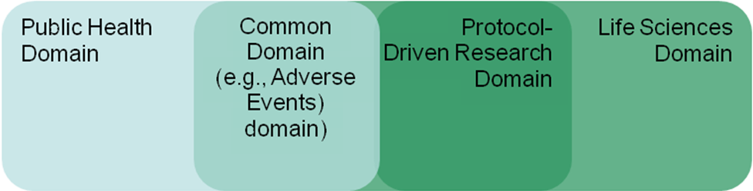

Figure 6: Overlapping Domains-of-Interest.

Semantics from intersecting domains-of-interest (e.g. ‘adverse event’ in the Public Health and Protocol-driven research domains; or ‘observation,’ ‘person,’ or ‘organization’ concepts common to Public Health, BRIDG, and Life Sciences domains) are “harmonized” so that CSI is possible between the various domains.

Note that the notion of harmonization at domain-to-domain “touch points” (“intersections”) may not be limited to static data, but may also involve interoperability/shared semantics regarding dynamic behavior.

As mentioned in the discussion of the genesis of the BRIDG Model (Section 3), a DAM is useful in separating domain-specific (implementation-independent) semantics from implementation-dependent semantics and is therefore helpful in identifying true cross-domain intersection points that may need to be harmonized.

UML: the BRIDG Model’s Representational Language
The graphical lingua franca of the BRIDG Model is the industry standard Unified Modeling Language (UML). To date, the iconography and underlying language grammar of UML V2.1 have been sufficient to express all of the semantics of both the dynamic and static views of the domain of the BRIDG Model.

Disease-Specific Model Strategy
Early in the history of BRIDG, the team considered including disease-specific classes, such as for cancer staging and identification of metastasis sites, but decided that the number of disease-specific classes would significantly expand the model until it was utterly unmanageable. Also, since most diseases require understanding of semantics that are disease-specific and not common to protocol-driven research in general, the modeling team should be comprised of modelers familiar with those diseases. Thus it was determined early on that the BRIDG SCC would harmonize the common semantics used in protocol-driven research across many different areas of study and leave the disease-specific semantics to teams who would create models based on existing BRIDG classes and patterns. The BRIDG SCC welcomes input from such teams who would like to propose semantics they need that they believe are common to protocol-driven research and two or more diseases.

BRIDG Representational Conventions

Study Lifecycle and the Grouping of Activities into “Pillars”
The BRIDG Model spans the lifecycle of a study from the planning of a study through the implementation, execution and evaluation of the study. Consequently, the model represents several stages of activities. Since BRIDG is a domain analysis model, the BRIDG SCC’s intention is to represent each concept in a domain-friendly way while being analytically rigorous. Thus the team has attempted to represent each concept once, in the context in which it originates and link to it in other contexts as needed. This allows the BRIDG Model to define only the attributes and relationships required for each context, thus eliminating much of the perceived redundancy in the model.

Defined Context (Global)
Defined activities are the characterization of a kind of activity, i.e. they define “what” an activity is. Most activities included in a study are not completely brand new, rather they are usually common tests or procedures, or they may be composite activities that are composed of several component activities that form a standard treatment strategy or a new treatment strategy used in several different studies. These activities are reusable concepts that essentially form a global library of activities that can be referenced in studies being planned, implemented, executed and evaluated. These activities can be defined once and referenced in many different studies to save the time and effort of re-entering data and, more importantly, to make the semantic connection between an activity being used in two different studies or at two different points in the same study. This notion of activities being defined once and referenced in many studies is the core idea of the defined activity class and its subclasses. This part of the model is what the BRIDG SCC calls the “Defined Pillar”.

Planned Context (Study Specific)
Planned activities are the association of defined activities to a particular study. This association also includes the characterization of the sequencing (or timing) of these activities, also referred to as the study calendar or study design. For example, a defined activity is created for the notion of allocating subjects to arms on a study; however, the notion of when it occurs in the context of a particular study and the method to be used is characterized in a planned activity. This part of the model is what the BRIDG SCC calls the “Planned Pillar”.

Scheduled Context (Subject Specific, future)
Scheduled activities are the instantiation of a planned activity for each subject on a study; this is sometimes referred to as the subject calendar. The scheduled activities also identify the intended timing of the activity as well as any anticipated resources (participants, locations, etc.) required for the activity. This part of the model is what the BRIDG SCC calls the “Scheduled Pillar”.

Performed Context (Subject Specific, past)
Performed activities represent the execution of activities for actual subjects on a study and the results that come out of those activities. Because domain experts have identified a need to capture what was actually done to a subject, as opposed to what was intended to be done. This makes it appear like there is redundant data in the BRIDG Model, e.g., the attributes in DefinedSubstanceAdministration vs. PerformedSubstanceAdministration. But in reality the attributes in the defined activity characterize what was intended and the attributes in the performed activity characterize what was actually done. Performed activities may reference a scheduled activity that they fulfill. Or, a performed activity may reference a planned activity in cases of a contingent activity, e.g., in the case of an adverse event a contingent activity may be planned but it is not scheduled. Or, a performed activity may be related directly to a defined activity in case of a totally unplanned activity such as when a subject breaks a leg and has emergency surgery that is considered study-relevant due to possible drug interactions. This part of the model is what the BRIDG SCC calls the “Performed Pillar”.

From the above descriptions, it should be clear that the “pillars” are essentially related areas of the model and that naming them helps provide language to discuss issues that occur during the lifecycle of the study.

Identifier Type
Some concepts represented in the BRIDG Model use an identifier to distinguish between different instances of the same concept. When a given model concept has the possibility of being assigned more than one identifier from different sources and/or purposes, there is a need to distinguish one identifier from another by type. For example, a person may be assigned a medical record number (MRN) as well as a social security number (SSN), driver’s license number, and insurance number. To distinguish one number from another, a type needs to be associated with each identifier. However, the HL7/ISO data type for Instance Identifier (II) is intended to be a universal identifier only – it intentionally does not identify the kind of identifier. The II.identifierName data type attribute is not to be used to computably determine the type, source, or any kind of meaning for the identifier. The pattern for identifiers that require identification of a type is to move the identifier attribute into its own class and add a typeCode attribute to capture the type of that identifier. Optionally, the new identifier class may be associated to an assigning entity (organization, study registry, or system of record). Thus each identifier has a one-to-one association with its type and each class requiring a typed identifier can have a one-to-many association with its identifier class. An example of this in the BRIDG Model is BiologicEntityIdentifier.

Constraints
In previous versions of the BRIDG Model, numerous notes were included on diagrams to identify business rules about relationships, attribute values and other kinds of logical constraints. In release 3.0, the SCC has converted all such notes into constraints. To ensure they are visible in diagrams and portable when the same class is included on multiple diagrams, the SCC has decided to define all constraints at the class level (attribute level constraints are not visually represented). We have four types of constraints to date:
- Exclusive Or – used to specify that only one of several similar associations can be used for any given instance of the class
- Not Applicable – used to indicate that an attribute or association is not used in a certain context such as on a subclass that inherits an association that applies to the superclass but not this subclass
- Unique – used to indicate that the value of a name attribute should be unique
- Qualifier – used to restrict a value on an attribute, to require or disallow a certain association in a specific situation, and generally capture other kinds of business rules
Note that the SCC may add other types of constraint in the future as a pattern for handling other kinds of business rules.

Relative Timing of Activities
Study Protocols often require an activity to occur some amount of time before or after another activity, i.e. the timing of such activities is relative to other activities. BRIDG uses a pattern for modeling such relative timing that is drawn from HL7. The association between the relatively timed activity and the activity that it references (the anchor activity) is represented with a relationship class that carries an attribute called pauseQuantity. The pauseQuantity attribute has the data type PQ.TIME, meaning it represents a quantity of time. The relatively timed activity occurs “X” number of minutes, hours, days, etc. after the anchor activity. An example of this in the BRIDG Model is PlannedContingentOnRelationship.pauseQuantity which defines how long after the prerequisite (anchor) activity occurs that the contingent (relatively-timed) activity occurs.

Automated Coding and Modified Text
Some concepts in the BRIDG Model are represented by a code that is determined by an automated coding application. Automated coders translate the original text into a code if the original text is something it recognizes and can parse. However, if there is a typo or unknown wording, etc., the auto-coders are unable to process the original text. Human intervention is required to interpret the text and provide corrected or modified text to allow the auto-coder to do its job.

However, the HL7/ISO data type called Concept Descriptor (CD) does not include an attribute for such modified text. Thus in cases where the BRIDG Model captures a concept that may be auto-coded, the class also includes a modified text attribute to capture the corrected text. Examples of this in the BRIDG Model are Product.nameCodeModifiedText and PerformedObservationResult.resultCodeModifiedText.

Color Coding of Classes in the UML-based Diagrams
In BRIDG Release 3.0, the class color coding convention has been changed to reflect the sub-domain that a class belongs to. One of the guiding principles of the Release 3.0 UML-based model was to remove the RIM aspects so that these diagrams would be easier to understand for domain experts. In previous releases, the classes had been color coded to RIM conventions. The color coding legend is on each of the BRIDG UML diagrams and is also included below.

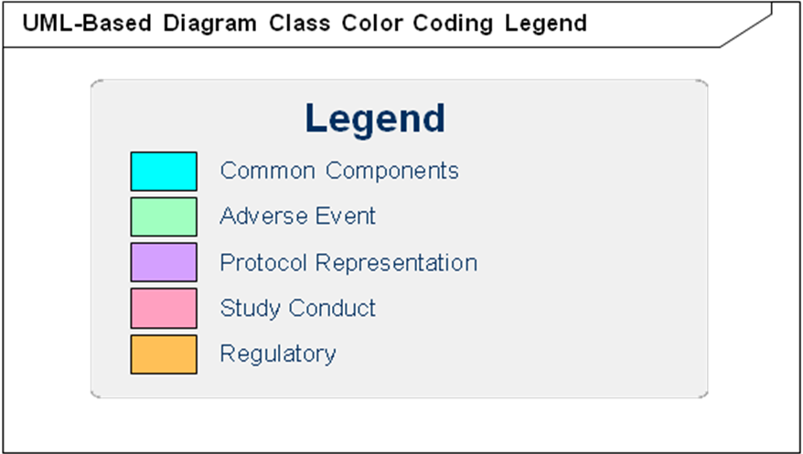

The Versioning of Study Protocol
Versioning is the process of storing the history of changes for an item, usually a document. Versioning allows viewing previous editions of an item, comparing it to the current live version, and, if desired, reverting to a previous edition. Within BRIDG the primary concept that requires versioning is the Study Protocol. The term “study protocol” has multiple meanings within the domain of protocol driven research, each used in a different context. “Study Protocol” is sometimes used to refer to the physical document that is reviewed. It is sometimes used to refer to the detailed plan for the study. And, it is sometimes used to refer to the activities of conducting the study. The BRIDG Model has a class for each of these concepts; StudyProtocolDocument, StudyProtocol, and StudyExecution, respectively. The StudyProtocolDocument class is a sub-class of the Document class. Because a study protocol can change over time (both the document and the plan) it became necessary to define versioned classes for Document, StudyProtocolDocument, and StudyProtocol. There are currently no use-cases for versioning of StudyExecution.

Just as it is necessary to review all attributes and relationships for study protocol and assign them to the appropriate study protocol class (StudyProtocolDocument, StudyProtocol, or StudyExecution), it is necessary to review all attributes of the study protocol classes and determine if they should be assigned to the versioned classes. The criteria the BRIDG SCC used to determine if an attribute or relationship should be assigned to the versioned class was if a change in that attribute or relationship might require an amendment to the protocol (and subsequent approval) it belongs to the versioned class. It quickly became apparent that almost anything relating to a study protocol could change and could require an amendment. This is evident in the BRIDG Model as most of the attributes and relationships ended up in the versioned classes.

There are many things related to study protocol that were evaluated as part of this exercise; personnel, resource, sites, agents, and activities. Most of these relate to both the versioned and non-versioned classes of study protocol. Study sites were one of the exceptions. This class was split into StudySite and PlannedStudySite; where PlannedStudySite relates to StudyProtocolVersion (as part of the study plan), and StudySite relates to StudyExecution (as part of the conduct of the study). The other exception is the activity classes. The DefinedActivity and PlannedActivity classes are related to StudyProtocolVersion (through StudyActivity) because they are part of the definition of the study plan that could change with each version. The PerformedActivity class is also related to StudyProtocolVersion; not because they are part of the plan, but because it is important to know under which version of the protocol a given activity was performed.

Model Content

Overview
As the BRIDG Model has grown in size and complexity it became increasingly difficult to satisfy the diverse audiences of BRIDG in a single model. Beginning with Release 3.0 the BRIDG Model has contained multiple perspectives (see Figure 7 below). The Canonical Perspective is a single UML model of the harmonized semantics. The Subject Matter Expert (SME) Perspective is comprised of several UML models using domain-friendly terminology. The HL7 Perspective is comprised of several HL7 models representing the harmonized semantics using unambiguous RIM constructs. The Ontological Perspective will be comprised of several OWL-DL representations and is intended to be used for semantic validation and inferencing.

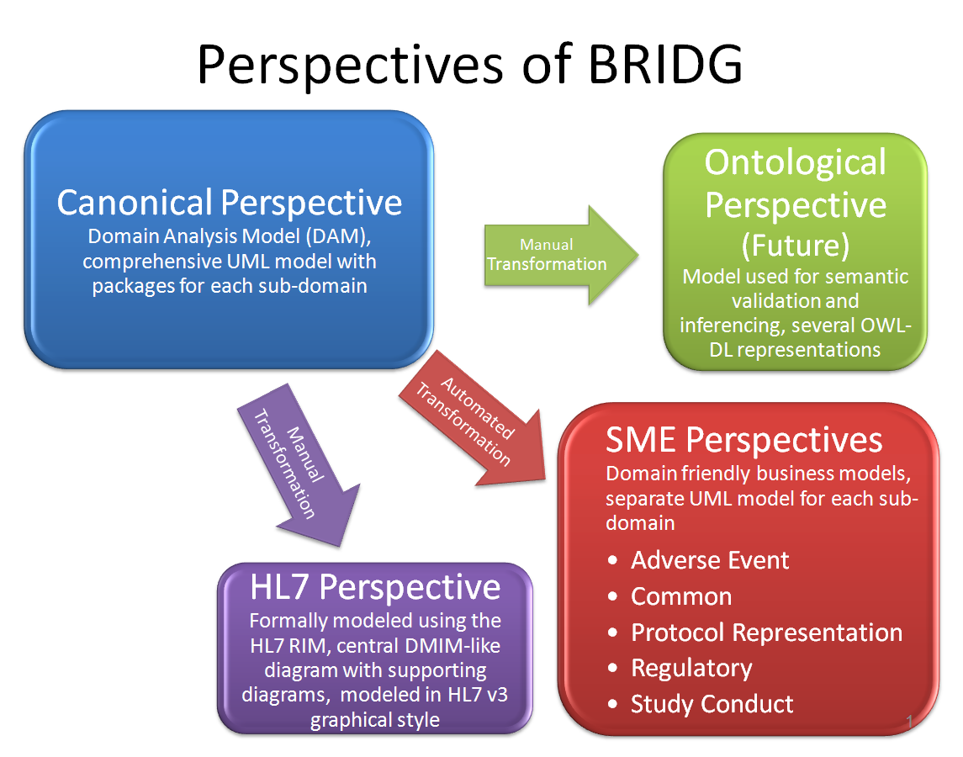
Figure 7: Diagram depicting the BRIDG multi-perspective approach

Canonical Perspective
The intended audience for the Canonical Perspective is primarily the SCC, but could include anyone interested in a comprehensive view of the semantics of BRIDG. This audience should be technically savvy and have a good understanding of semantic modeling. The intent of the model in this perspective is to define how the semantics in the SME Perspective are integrated.

The master BRIDG semantics are maintained in a UML model. UML is a standardized general-purpose modeling language used to specify semantic requirements for a particular domain. UML offers a variety of diagrams to visually represent the semantics; BRIDG uses primarily class and instance diagrams.

Canonical Perspective to SME Perspective Transformation
The Canonical Perspective is considered the master version of BRIDG and the models in the SME Perspective are merely representational views of subsets of the semantics in the Canonical Perspective. Given that relationship between the two perspectives, it is important to ensure that the underlying semantics are in sync. To facilitate this, tools are used to automatically generate the models for the SME Perspective based on information embedded in the Canonical Perspective. As part of this process, “transformation” tags are included in the classes and attributes of the Canonical Perspective that indicate what should be transformed. For example, the Adverse Events sub-domain model in the SME Perspective uses the class name “InvestigativeSubject” instead of the Canonical Perspective class name of “Subject”. So the “Subject” class has a transformation tag in it that indicates that for the Adverse Events sub-domain, use the alias of “InvestigativeSubject”.

Canonical Perspective to HL7 Perspective Transformation
Since the HL7 Perspective is a representational view of the semantics in the Canonical Perspective using HL7 syntax, it is important to ensure the underlying semantics in the HL7 Perspective and the Canonical Perspective are in sync. There are no tools to automatically generate the HL7 models; therefore qualified HL7 modelers must perform this transformation manually.

Subject Matter Expert Perspective – Sub-Domains
The intended audience for the Subject Matter Expert (SME) Perspective is domain experts. These are non-technical people who need to verify the accuracy of the semantics captured in the BRIDG Model. The intent of the models in this perspective is to allow these domain experts to view the models and “see” their business. However, since the scope of BRIDG is so large, domain experts in one area may use different terms than domain experts in another area. For this reason the SME Perspective will contain several sub-domain models. When the same class appears in more than one sub-domain, it is essentially structurally the same, but may have aliases at the class or attribute level and may have some attributes hidden if they are not needed in one sub-domain but are used in another. Within the SME Perspective there are currently five sub-domains defined. Other sub-domains may be defined as needs arise.

Protocol Representation
The Protocol Representation sub-domain is intended for those involved in the planning and design of a research protocol. The majority of business requirements have come from those involved in clinical trial protocols. It focuses on the characteristics of a study and the definition and association of activities within the protocols, including “arms” and “epochs”. It also includes the definitions of the roles that participate in those activities.

Study Conduct
The Study Conduct sub-domain is intended for those involved in the execution of a research study. The majority of business requirements have come from those involved in clinical trials. It focuses on the activities of conducting the study as well as the results from those activities.

Adverse Event
The Adverse Event sub-domain is intended for those involved in safety related activities; such as detection, evaluation, follow-up and reporting. This includes safety issues involving people or products. It also includes safety-related activities during or after a research protocol.

Regulatory
The Regulatory sub-domain is intended for those involved in the creation and review of submissions to regulatory authorities (aside from safety-related submissions which are covered in the Adverse Event sub-domain). The majority of business requirements come from the Regulated Product Submission (RPS) model. It focuses on the documentation required for a product submission to the US Food and Drug Administration (FDA).

Common
The Common sub-domain is not intended for any one specific audience. It represents the semantics that are common to all (or most) of the other sub-domains. Most of the content is not even specific only to the BRIDG domain but might be common to any healthcare-related domain analysis model; and includes semantics for such things as people, organizations, places and materials.

Analysis and Reporting
A person familiar with the clinical trial process might legitimately ask the question: “I see the phases of ‘planning’, ‘scheduling’ and ‘performing’; where are ‘analyzing’ and ‘reporting’?”

With respect to the concept of “analysis,” the SCC has not yet been presented with specific requirements and harmonizable artifacts that have resulted in the need to have these specific concepts represented in the BRIDG Model. It is a virtual certainty that the concept of ‘analysis’ will emerge in the very near future. The SCC chose not to include a placeholder class called “Analysis Activity” because there is not yet a high-level agreement as to the semantics of this concept.

With respect to the concept of “reporting”, it will most likely not occur as a general concept in the BRIDG Model since a report should be simply a collection of specific data. (The notable exception to this statement is the case of Adverse Event or Regulated Product Submission “reports,” each of which collects data in known formats.) If a DAM attempts to explicitly represent each individual report by type and attribute collection, it quickly degenerates into an intractable model that, on the one hand, purports to be a class diagram but is, on the other, an ever-expanding instance diagram.

HL7 Perspective – RIM-based
The HL7 Reference Information Model (RIM) is a highly abstract comprehensive information model for the healthcare domain. “Healthcare domain” is interpreted broadly encompassing such areas as:

- clinical care (inpatient and outpatient)
- healthcare administration
- reimbursement
- community care
- veterinary care
- genomics
- imaging

Because of its breadth, the RIM tends to use generic class, attribute and association names that are not necessarily domain-friendly. In addition, the RIM is completely free of the constraints and business rules that apply to domain-specific models. Its purpose is to provide a single set of reference semantics that can be leveraged across all healthcare domains. Additional, more specific, models are then created with strict derivation relationships to the RIM to support the implementation of communication interfaces.

Although the RIM is, for the most part, relatively free of implementation details, it is not a DAM because, as just mentioned, it is not readily understandable by domain experts in any one of the listed domains (e.g., “Where are vaccinations in the RIM?”, “How do I represent a provider credential?”, “Where is a SNP found?”, etc.), a fact that arises from the requirement that the RIM be an abstraction of cross-domain semantics. However, because it is important to the BRIDG stakeholders that BRIDG semantics be expressible in HL7 XML, the SCC is responsible for ensuring that BRIDG semantics can be represented in RIM structures. If this is not the case, the SCC works with project teams to bring their specific semantics to HL7 for harmonization of the RIM, i.e. expansion of RIM semantics. To date, only a handful of such instances have been identified; some of these have already been submitted and been incorporated into the RIM. Others may need to be submitted in the future.

NOTE: Saying that BRIDG semantics are mappable to the HL7 RIM does not mean that the mappings are one-to-one, e.g. attribute to attribute. In fact, they are most often not of that nature., i.e. a BRIDG class doesn’t often map to a single RIM class (exceptions being concepts like “Person”) and, likewise, a single attribute in the BRIDG Model may map to a combination of RIM attributes or a collection of RIM data type properties. The details of the mapping are not important. Semantic equivalence is the critical issue.

In some cases, RIM patterns have influenced BRIDG Model design where they have accurately reflected requirements and made sense from a domain perspective; for example, separating entities from the roles that played them, using ‘typed’ relationships between kinds of Acts, etc. In addition, some BRIDG attributes share the same name as the ‘equivalent’ attribute from the RIM. However, BRIDG is not truly a RIM based model. It contains numerous classes, attributes and associations that are not directly derived from RIM classes, attributes and associations. This was necessary to ensure BRIDG served its primary purpose as a domain-friendly model.

Custom UML leveraging domain-friendly business names and putting attributes where-ever domain experts feel they make the most sense works extremely well for a domain analysis model. However, it does not work as well when the time comes to exchange data in a standardized manner or to map BRIDG concepts to HL7 communication specifications. For HL7, this communication needs to occur using instances based on static models that are strictly derived from the RIM. Because there is no strict derivation of the BRIDG Model itself, an additional set of models were needed. These RIM-based BRIDG Models mirror the content of the BRIDG but are created using HL7 tooling to ensure strict derivation from the RIM.

The HL7 perspective presents the same semantics as in the UML model but using HL7 RIM classes grouped into a central DMIM diagram and a number of supporting diagrams. The HL7 models are constructed using HL7’s Visio RMIM Designer tool and thus have a different graphical representation than a typical UML class diagram. However, the underlying constructs are all UML. The HL7 models have been carefully crafted to represent each of the associations and attributes present in the BRIDG domain analysis model. In some cases, a BRIDG attribute may be represented as the presence or absence of an HL7 association. In addition, HL7 requires many attributes that are not found in BRIDG. These are assigned fixed values and help to define the semantics of the HL7 model.

To allow cross-referencing between the BRIDG Model and the HL7 models, mapping annotations are captured within the HL7 classes and attributes identifying the BRIDG class, attribute or association end that corresponds to each element. Cross-reference reports are then generated to ensure a consistent representation between the UML and HL7 representations. In a few cases, mappings will not be one-to-one. This happens most frequently on status codes and similar coded attributes where the semantics found within a single BRIDG attribute must be spread out across multiple RIM attributes to adequately represent the semantics. In these circumstances, the mapping includes a conditional clause that identifies what “subset” of the BRIDG attribute semantics map to a particular RIM attribute.

While the BRIDG HL7 models are “standard” HL7 models, they are not intended to be used directly as the foundation for exchanging messages. Instead, they serve as a basis of discussion with other HL7 groups who are modeling content relevant to BRIDG. By having the BRIDG semantics clearly expressed in HL7 terms, it will be easier to ensure that BRIDG requirements are incorporated in the various HL7 standards specifications related to the domains covered by BRIDG.

Ontological Perspective
The Ontological Perspective will be represented in OWL-DL format. OWL (Web Ontology Language) is a knowledge representation language for authoring ontologies. The SCC has used OWL to provide a means of validating the semantics of BRIDG against other ontologies (e.g., the HL7 RIM). A formal OWL version of BRIDG will be maintained in the near future. The method for transforming the UML model to the OWL representation will also be determined in a future release.

Relationship to other DAMs
The domain for other DAMs (such as the Life Science DAM, the Tuberculosis DAM, or the Cardiology DAM) may intersect or overlap with the domain of BRIDG. (See section 2.3 for the formal definition of the domain for the BRIDG Model.) In these cases, the common semantics must be reconciled; BRIDG, the other DAM, or both should be changed to bring the DAMs into alignment.

Source Model Mappings
While there are mappings between various perspectives in the BRIDG Model, there is also a need for mappings between the BRIDG Model and the source models and projects whose semantics have been harmonized into BRIDG. Such information is useful to the BRIDG SCC so that they know the impact of any model changes under consideration, but also to the users of the BRIDG Model so that they know where their harmonized semantics “landed” in the BRIDG Model.

With BRIDG 3.0, the SCC introduced a new convention for Mapping Tags in the EA file. Each class and attribute has one or more tags indicating the source model element from which the concept was derived or to which the element maps. The tags are comprised of a tag name indicating the type of tag and the source model (e.g. Map:AE) and a tag value indicating the name of a source model element (usually a class and attribute name).

The BRIDG SCC also maintains an internal document, an Excel mapping spreadsheet, that includes additional information, such as the full path of mappings for when a source concept spans more than one BRIDG class, “where clause” criteria or conditions that may apply to mappings, source model elements deemed implementation-specific, source model elements that remain a gap in BRIDG, etc.

It should be noted that the relationships shown in a given entry in a mapping document are often not one-to-one and often not at the same level of abstraction between the two models. The mapping documents form an essential part of the BRIDG knowledge base that project teams will use as they both begin new projects and extend existing ones.

Views (Diagrams)

BRIDG – Start Here: Overview
Users unfamiliar with BRIDG should read this view. It provides an overview of BRIDG project.

BRIDG Domain Analysis Model: BRIDG Sub-Domain Packages Diagram
This diagram shows the five sub-domains and the classes in each sub-domain.

BRIDG Domain Analysis Model: UML-Based Comprehensive BRIDG Model
This view shows the complete BRIDG Model (current release) and specifically shows, for each class where it's applicable, the complete set of attributes for the class, partitioning the attributes as to whether they are "local" to the class or inherited from the class' super-type hierarchy.

Sub-Domain Views
These views show a subset of the BRIDG Model specific to a particular sub-domain. Each sub-domain is defined in a package within the BRIDG Model. Each package may contain many diagrams, but they must contain at least one “comprehensive” view for that sub-domain.
- View AE: Adverse Event
- View CM: Common
- View PR: Protocol Representation
- View RG: Regulatory
- View SC: Study Conduct

Class Diagrams
Class Diagrams are the lingua franca for representing the concepts, attributes, and relationships that define the static semantics of the domain of the BRIDG Model.

Instance Diagrams
Instance diagrams aid domain experts with no prior UML experience in reading, understanding, and validating, the content of the BRIDG Model. They are useful for exploring “real world” examples of objects and the relationships between them. Instance diagrams look similar to class diagrams, except the classes and attributes contain real world examples of data values so that one can see what types of data are expected.

State Diagrams
State Diagrams depict the possible life cycle stages and legal transitions that an instance of a given concept may undergo during its existence and are associated with a small percentage of BRIDG static concepts. In common modeling practice, approximately 10% of classes in a given class diagram have sufficiently interesting life cycles to warrant an associated State Diagram. All classes for whom state is of interest carry an obligatory “statusCode” attribute.

The essential semantics of a UML State Diagram are:
- State (including “initiate” and “final status”)
- Transition
- Guard (optional and not currently used in BRIDG)
- Intra-state Activities (not currently used in BRIDG)

The BRIDG Model includes several state transition diagrams representing several status code attributes which needed to be elaborated for the purposes of accurately representing the UML-based semantics in the RIM-based model. Note that ALL the state diagrams are considered DRAFT at this time. These diagrams include:
- Defined Activity Status
- Scheduled Activity Status
- Performed Activity Status
- Processing Status
- Review Board Approval Status
- Study Overall Status
- Study Site Accrual Status
- Study Subject Status
- Submission Status

Release Package
The BRIDG release package includes all materials collected and published as a formal release of the BRIDG Model. These artifacts are gathered in a single package (ZIP file) and posted to the BRIDG GForge site (http://gforge.nci.nih.gov/frs/?group_id=342).

- UML-Based Models
The UML representation of the BRIDG Model is represented in Enterprise Architect from Sparx Systems (which is an .EAP file). A UML modeling tool such as Enterprise Architect supports the development of a model as a collection of dynamic and static semantics which are represented in multiple views (e.g. Class, Instance, and State Diagrams) as described above.

NOTE: A viewer which enables full traversal and inspection of the complete BRIDG Model can be downloaded from the Sparx Systems website (http://www.sparxsystems.com.au/).

The specific file names in the Release Package in this category are:

- BRIDG 3.0.2 Comprehensive Domain Analysis Model.EAP
- BRIDG 3.0.2 Adverse Event Sub-Domain Model.EAP
- BRIDG 3.0.2 Common Sub-Domain Model.EAP
- BRIDG 3.0.2 Protocol Representation Sub-Domain Model.EAP
- BRIDG 3.0.2 Regulatory Sub-Domain Model.EAP
- BRIDG 3.0.2 Study Conduct Sub-Domain Model.EAP
- RIM-based Models
The RIM-based part of the BRIDG Model is represented in files with the JPG format, which are images of the VSD files created in the HL7 Visio Tool.

While the BRIDG HL7 models are “standard” HL7 models, they are not intended to be used directly as the foundation for exchanging messages. Instead, they serve as a basis of discussion with other HL7 groups who are modeling content relevant to BRIDG. By having the BRIDG semantics clearly expressed in HL7 terms, it will be easier to ensure that BRIDG requirements are incorporated in the various HL7 standards specifications related to the domains covered by BRIDG. For this reason, this part of the model is being presented using PNG rather than schema, Visio, or MIF files.

The RIM-based models are in the BRIDG RIM Model directory of the Release Package. The document summarizing the background on the content of the RIM models, how they're organized, filename conventions, etc. is:

- BRIDG RIM Representation.pdf
- Report of Comprehensive UML-Based Model
The release package also contains an RTF report for all the static elements in the BRIDG Model. This was generated from the Enterprise Architect file and can be viewed with Microsoft Word.

The specific file names in the Release Package in this category are:

- BRIDG 3.0.2 Comprehensive Domain Analysis Model.RTF

Users and interested parties can generate similar RTF reports for other packages by following the steps listed below:

- Highlight the desired package in the Project Browser.
- Right click on the package and select Documentation -> Rich Text Format (RTF) Report.
- Click Switch Generator.
- For Output Filename, click the browse (…) button to locate the folder and file name in which you wish to save the RTF report.
- Select the desired items you wish to appear in the RTF report from the “For each Object Include” section.
- To include the diagrams in the RTF report, click the “Embed Diagrams in Document” box under “Options”.
- Select the desired “Diagram format” from the radio buttons.
- Click Create under the “Document” section.
- A success message will appear when generation is complete.
- XMI of Comprehensive UML-Based Model
Readers interested in a serialized, non-graphical version of the model can use the XMI file that is part of the BRIDG release package. It is the representation of the model that is generated by the Enterprise Architect tool as using the somewhat-less-than-standard XML Metadata Interchange (XMI) format.

The specific file names in the Release Package in this category are:

- BRIDG 3.0.2 Comprehensive Domain Analysis Model.xmi

NOTE: There are known problems with this format and, as such, the XMI version of the BRIDG Model is not considered to be canonical.
- Release Notes
The release package also contains a summary of changes made from the previous version of BRIDG.

The specific file names in the Release Package in this category are:

- BRIDG 3.0.2 Release Notes.doc
- User’s Guide (this file)
This document covers the background and organization of the BRIDG Project as well as detailed description of the content and use of the BRIDG Model.

The specific file names in the Release Package in this category are:

- BRIDG 3.0.2 User’s Guide.doc
- BRIDG R3.0.1 to 3.0.2 Change List
As mentioned above, the detailed list of changes to classes, attributes and associations is documented in spreadsheet contained in this release package.

The specific file names in the Release Package in this category are:

- BRIDG 3.0.1 to 3.0.2 Change List.xls
- BRIDG Mapping Spreadsheet
This document provides a mapping of the classes and attributes from source project models to classes and attributes in the BRIDG model. This document also includes additional information, such as; the full path of mappings for when a source concept spans more than one BRIDG class; “where clause” criteria or conditions that may apply to mappings; source model elements deemed implementation-specific; and source model elements that remain as gaps in BRIDG.

The specific file names in the Release Package in this category are:

- BRIDG 3.0.2 Mapping Spreadsheet.xls

Glossary
Domain Analysis Model (DAM): A DAM is a conceptual representation of an area of interest. It is used for conveying an understanding of the domain and allowing that understanding to be assessed by others to aid in reconciling multiple perspectives of the domain.

The term “domain analysis model” (DAM) has at least two distinct meanings in the literature. Consistent across both definitions (which are essentially differences in content and scope of included domain information) is the notion that a DAM is implementation independent, i.e. it restricts itself to describing the “what” of the domain-of-interest, specifically excluding any representation of the various aspects of the “how.” This distinction results in a representation that is “domain-friendly,” i.e. the terms and constructs used in a DAM can easily be understood by domain experts. (NOTE: A DAM is vettable by domain experts because it is expressed in terms familiar to those domain experts rather than in “techno-speak.” The latter is the appropriate language of a design and/or implementation-specific model. It should be noted that a single DAM can give rise to multiple design models, each a specific set of measured compromises on the original DAM semantics). A DAM can be vetted by domain experts while simultaneously providing sufficient rigor for “downstream” design and implementation activities. This is a critical, essential defining feature of a DAM, and results in the fact that a single DAM can give rise to N-number of compliant implementations that vary in everything from UI to persistence schema, but remain computationally semantically interoperable by virtue of their implementation of various semantic constructs of the DAM on which they are based. As discussed in the text, the BRIDG Model – itself an instance of a DAM – was begun to provide an implementation-independent view of the static and dynamic semantics of a domain-of-interest that could be shared initially by HL7 and CDISC and more recently by HL7, CDISC, NCI, and FDA.
The two meanings of the term DAM are: 1) Static content only. The more restrictive meaning of the term defines the scope of a DAM to be the definition, explication, and inclusion of the static structures-of-interest in the domain-of-interest. No dynamic content is included. Thus, if the DAM is represented using the iconography of the Unified Modeling Language (UML) -- the representational language of the BRIDG domain analysis model -- the restrictive use of the term means “the semantics specified by the collection of classes, instances, attributes, and relationships that collectively define the domain-of-interest.” 2) Dynamic and static content. The more inclusive use of the term DAM – and the one that defines the scope of the BRIDG Model – allows for a DAM focused on a specific domain-of-interest to include both static and dynamic content, i.e. to be an “analysis-level architectural representation of the domain-of-interest.” Again, referring to the use of UML, a “type 2 DAM” would include all of the static content of a “type 1 DAM” plus the additional semantics of various dynamic aspects of the domain-of-interest expressed as Activity Diagrams of various granularities, State (lifecycle diagrams), and Sequence Diagrams. By far the most common of these three dynamic views are Activity Diagrams. State Diagrams are usually required for < 10% of the classes in the static class diagram view, and Sequence Diagrams are usually restricted to understanding specific “interoperability scenarios” at an <<instance>> rather than “responsible party” level common to Activity Diagrams. NOTE: In both usages, the term “domain analysis model” is also synonymous with the term “Problem Space model.”

RCRIM Work Group: An HL7 Work Group, the Regulated Clinical Research Information Management Work Group supports the HL7 mission to create and promote HL7 standards by developing RCRIM standards to improve or enhance information management during clinical research and regulatory evaluation of the safety, efficacy and quality of therapeutic products and procedures worldwide. This Work Group defines messages, document structures, and terminology to support the systems and processes used in the collection, storage, distribution, integration and analysis of such information. Areas of interest are Products and Studies generated as a result of protocol driven research in a regulated environment

semantics: The term “semantics” is used as a formal synonym for “meaning” as opposed to the term “syntax” which means “structure.” Thus, the two sentences “The dog eats red meat” and “The dog drinks blue sky” have the same syntax but very different semantics (one being sensible, the other being nonsense.) In contrast, the two sentences “The patient took medication for pain” and “Pain medication was taken by the patient” have the same semantics but markedly different syntax. DAMs focus on the semantics (dynamic and/or static) of the domain-of-interest and as such, there may be more than one syntax/syntactic representation (i.e. modeling construct) for the same semantic content. A given DAM will pick one of several syntactic representations of a given set of semantics.

state:
Definition of state: In computer science and automata theory, a state is a unique configuration of information in a program or machine. “The description of a particular phase in the lifecycle of an instance of a concept.” States are entered and exited via state transitions which are events that can occur either external to or generated by the state (e.g. the triggering of a time-based or non-time-based rule). A complete set of states and their respective entry and exit transitions define the set of all possible life cycles for all possible instances of a concept. Note that not all instances of a concept need pass through all possible states during their individual life time.

Appendix

Abstract and Complex Data Types
Definition of abstract data type (from Wikipedia): “In computing, an abstract data type (ADT) is a specification of a set of data and the set of operations that can be performed on the data. Such a data type is abstract in the sense that it is independent of various concrete implementations. The definition can be mathematical, or it can be programmed as an interface. The interface provides a constructor, which returns an abstract handle to new data, and several operations, which are functions accepting the abstract handle as an argument.”

Virtually everyone is familiar with the concepts of integer and character. Most people have little trouble moving from a single character to the concept of a string of characters. Integer, character, and string are often referred to a simple or primitive data types. In contrast, complex data types combine primitives (and other complex data types) to express increasingly complex semantics, e.g. notions of date and time, physical quantities, names, etc. In a computationally tractable model, each attribute in a Class Diagram must be of a single data type, be it complex or primitive.

Analysis models, being implementation-independent, are often not concerned with specifying a particular data type for a given attribute of an analysis-level class. Reasons for not specifying data types vary from not knowing enough about the implementation specifics of a given attribute to reliably specify a data type with any real accuracy, fear of confusing domain experts with notions of computational concerns that are outside of their realm-of-interest, and/or lack of a common data type standard that can be reliably applied to a given domain. However, there are certain times when it becomes necessary to define analysis-level complex data types to capture the semantics of a particular domain concept. The two most common reasons for defining a complex data type in the context of a given analysis model are:

- a set of attributes that have inter-relationships (e.g. a Value and a Unit for a given measurement such as 8 inches vs. 8 days)
- a set of attributes that is used as an attribute in multiple classes (e.g. a DateTime stamp)
In the case of the BRIDG Model the SCC has decided that to support the multi-stakeholder requirements for cross-organizational computable semantic interoperability around which the BRIDG Project was initiated, and given the existence of the HL7/ISO data types, an ANSI and ISO-approved data type specification specifically developed for the domains of Healthcare, clinical research, and life sciences, the BRIDG Model should move to a point where each attribute in the static representation (Class Diagram) will be assigned to a specific HL7/ISO data type. The SCC has made this commitment for several reasons:

- The need for complex data types in the BRIDG Model (e.g. for coded concepts and various complex timing specifications) is becoming ever more clear;
- The increasing emphasis of BRIDG as a key component in application development (where data type definition is critical to final interoperability requirements);
- The viability and world-wide vetting of the HL7/ISO data type specification has made it a natural choice for a DAM that lives within the composite domains-of-interest of HL7 (which BRIDG clearly does);
- The SCC’s belief that, to domain experts, the concept of an Abstract Data Type is either interesting or understandable, or uninteresting and unimportant, but in neither case distracting to the overarching problem of robustly defining domain knowledge using UML/BRIDG constructs.

At the time of publication of this document, the HL7 / ISO data type specification can be found at http://www.hl7.org/v3ballot/html/infrastructure/its_r2/ISO%2021090%20Healthcare%20Datatypes.pdf.

Temporal Grammar(s): HL7/ISO Data Type TS Data Type
The inherent temporal complexity of a clinical trial – that is, the importance of expressing complex timing relationships between planned, scheduled, and performed activities as well as activities and events that occurred as either outside the scope of the trial or as unplanned or out of sequence within the context of the trial – requires that complex temporal semantics be captured from domain experts. From a computational perspective, this requirement is best stated by saying that the model requires a temporal grammar. To date, the HL7/ISO data type Timing Specification (TS) meets most (if not all) of the requirements for such a grammar. As such, the SCC uses that data type’s semantics in the UML-based portion of the BRIDG Model.

Coded Concepts: HL7/ISO Data Type CD Data Type
The SCC has liberally used the CD complex data type through the UML-based part of the model to emphasize the consistent message from domain experts of the importance of the use of coded concepts rather than free text in capturing critical clinical trial information for computational analysis (e.g. reporting, cross-trial data pooling, etc.). It should be emphasized that the assignment of a given BRIDG attribute to the CD complex data types does not mean that the SCC believes that a standardized set of coded concepts exist. Rather, the use of coded concepts most often begins with a locally-defined set of concept codes which, over time, is harmonized with other locally-defined sets of concept codes for similar purposes to eventually produce a standardized set of codes that can be used by all systems collecting data in a given context. At the point where a single set of coded concepts for a given concept exists, true computational semantic interoperability is realized.

Collections: BAG, SET, and LIST
Computational representations of collections of things recognize three types of collections with differing semantics:

- BAG – a collection of elements in which redundancy/non-uniqueness of elements may occur (for example, the set of all names of all persons participating in a specific clinical trial)
- SET – a collection of elements without order but with a guarantee of element uniqueness (e.g. the set of all participants in a given clinical trial)
- LIST – a collection of elements with both guaranteed uniqueness and a pre-determined order (e.g. an ordered set of steps defining a procedure)

The SCC has utilized these collection semantics as needed throughout the BRIDG Model.

Instances as “KindOf” vs. “InstanceOf” – holding a place vs. filling it
The separation of the Planning phase of a study from the Scheduling or Performing phases raises an issue of how to represent the notion of a ‘placeholder’ for a particular instance of a class vs. representing an ‘actual’ occurrence of that instance. For example, when in the Planning phase of a study, one speaks of ‘potential research subjects,’ counting their numbers and assigning them to activities as if they were ‘real,’ knowing that they are simply placeholders for ‘real’ research subjects that will be recruited once the study officially begins, and knowing that these various ‘real’ research subjects will then ‘replace’ the ‘placeholder’ instances that are referred to in the planning phase.

The BRIDG Model must, of course, deal with these concepts of ‘placeholder instances’ vs. ‘real instances’ of a given class (the best – but not only – example being that of BiologicEntity). This is done through an attribute called actualIndicator, a Boolean that will have the value N if the instance is a ‘placeholder’ and Y if the instance is, in fact, real. Thus, a PlannedActivity will be associated with a BiologicEntity instance whose actualIndicator attribute = N, whereas a ScheduledActivity or PerformedActivity will be associated with a BiologicEntity instance whose actualIndicator attribute = Y.

A Brief Explanation of the concept of “mood”
One of the most significant knowledge representation decisions made so far in the course of the BRIDG Project has been around the representational choices used to capture the well-known but not standardized representation of a somewhat obtuse concept that HL7 has named mood (manifest in the value of the moodCode attribute of the RIM class Act and its various subtypes.) The name of the concept comes from the world of grammar:

In linguistics, many grammars have the concept of grammatical mood (or mode), which describes the relationship of a verb with reality and intent. (Wikipedia)

The term is used in HL7 to distinguish “phases of a business process through which multiple instances of a concept can pass” from “state: the named phases of the life cycle of an instance of a concept.” If one studies this definition carefully, one realizes that the concepts of state and mood each describe different perspectives on complex business processes and workflow, state describing phases of the lifecycle of a single instance of the concept, while mood describes the phases of the business process itself, through which multiple instances – each in a different mood -- may pass. An example of a state is a PerformedActivity can be in the "aborted", "cancelled", "completed", or "on-going". All states in BRIDG are captured in the statusCode attributes of various classes. All of the statusCodes are then further specified in state diagrams, which can be found in the BRIDG State Transitions Diagrams section of the model. Examples for mood are further described below. For more details on the notions of mood and state, please see the HL7 website for the list of valid values for moodCode.

In the domain of BRIDG, there are several well-known phases of the clinical trial business process, e.g. Plan, Schedule, Perform, Report. In HL7 terms, these would be values of the moodCode of the various ‘Act instances’ that occurred during this ‘business lifecycle’ of a clinical trial that were collected within an instance of a particular Study). As is the case in many domains besides BRIDG, one finds that at the analysis model level, there are many common structures (i.e. classes and attributes) shared across business process phases. However, one also quickly discovers that there are small but essential differences, e.g. a Performed Activity is associated with a specific Study Subject whereas a Planned Activity is not, even though the two activities contain virtually identical information with the exception that the Performed Activity uses actual dates and the Planned Calendar uses relative dates. (A similar difference in “mood-based attributes” is found in clinical care when an order for a specific test does not contain a result value and contains somewhat different details of time specification, in many ways similar to the timing differences between a Planned Activity and a Scheduled Activity.)

Early versions of the BRIDG Model attempted to use a single attribute called businessProcessMode which was modeled directly off of the HL7 attribute Act.moodCode to simplify the model by allowing reuse of classes (with the caveat that there needed to be mood-specific restrictions on attribute usage). This approach was found to be too confusing and obfuscating to domain experts. As a result, the composite BRIDG Model contains explicit structural manifestations of each ‘mood’ of a clinical trial. Specifically BRIDG contains the ‘moods’ of "Defined", “Planned,” “Scheduled,” and “Performed.”

The separation of the Planning phase of a study from the Scheduling or Performing phases raises an issue of how to represent the notion of a ‘placeholder’ for a particular instance of a class vs. representing an ‘actual’ occurrence of that instance. For example, when in the Planning phase of a study, one speaks of ‘potential research subjects,’ counting their numbers and assigning them to activities as if they were ‘real,’ knowing that they are simply placeholders for ‘real’ research subjects that will be recruited once the study officially begins, and knowing that these various ‘real’ research subjects will then ‘replace’ the ‘placeholder’ instances that are referred to in the planning phase.
The BRIDG Model must, of course, deal with these concepts of ‘placeholder instances’ vs. ‘real instances’ of a given class (the best – but not only – example being that of BiologicEnity). This is done through an attribute called actualIndicator, a Boolean that will have the value N if the instance is a ‘placeholder’ and Y if the instance is, in fact, real. Thus, a PlannedActivity will be associated with a BiologicEntity instance whose actualIndicator attribute = N, whereas a ScheduledActivity or PerformedActivity will be associated with a BiologicEntity instance whose actualIndicator attribute = Y.

caBIG®: Using the BRIDG Model
Since many readers of this documentation may be more familiar with message specification development rather than application interaction and service development, this section provides an example of how NCI’s Cancer Biomedical Informatics Grid (caBIG®) is using the BRIDG Model to achieve interoperability goals in the Clinical Trials Management Systems (CTMS) Work Space (WS).

caBIG® CTMS WS Silver Compatibility: An Instance of Application Development Processes Using the BRIDG Model
Although there is, to date, no essential difference in the semantic representation requirements for use of the BRIDG Model as the basis for data interchange specification (e.g. CDISC or HL7 messages) vs. the basis for application interoperability (e.g. NCI CTMS WS application interactions and services), there are certainly differences in the perspective of a team using the BRIDG Model to define standards for static data interchange (i.e. system-to-system “messages”) vs. those using the BRIDG Model to drive application development and the exposure of Application Programming Interfaces (APIs). A specific instance of this difference in perspective can be seen in the process that is used in the caBIG® CTMS WS. While it is beyond the scope of this document to discuss the details of caBIG® compatibility certification, the BRIDG SCC believes that a brief review of the use of the BRIDG Model in this process is instructive to readers.

In summary, the sequence of steps is as follows:
- application teams begin their analysis activities by downloading the current release of the BRIDG Model;
- as they work on their specific requirements gathering and specification tasks, they add or modify the content of their instance of the BRIDG Model;
- in parallel, they derive a Mapping Document mapping their semantic requirements and model elements to the BRIDG Model and identifying gaps and new model content to fill the gaps;
- the team works with a BRIDG-knowledgeable analyst to ensure proper use of the existing BRIDG semantics and introduction of new semantics in a way that is consistent with existing patterns in BRIDG;
- at a point where the team believes it is ready to freeze its analysis artifacts (semantics are stable), it presents its “harmonizable BRIDG artifacts” (i.e. static and dynamic semantics represented appropriately in various UML diagrams as discussed above) to the SCC;
- a collective decision is made on each proposed mapping and changes, if necessary, are made both to the mapping document and to the BRIDG Model as appropriate;
- post-harmonization, the project team modifies its implementation to reflect semantic changes (e.g. disambiguations) in its initial analysis models;
- if necessary, the process is repeated;
- the project team’s final BRIDG-compliant specification is registered in the NCI cancer Data Standards Repository (caDSR) with BRIDG elements receiving unique Concept Unique Identifiers (CUIs);
- the project’s static analysis artifacts are processed by a series of caBIG® infrastructure tools resulting in the publication of BRIDG-compliant, registered APIs that can be accessed by other applications in the caBIG® infrastructure.

The use of the BRIDG Model as a fundamental piece of the CTMS WS infrastructure facilitates the process of building applications that can exchange data at a computationally semantically interoperable level.

BRIDG and the Four Pillars of Computable Semantic Interoperability
Computable Semantic Interoperability (CSI) rests on the four pillars identified in this section. This section also identifies how BRIDG addresses each of the pillars.

CSI Pillar #1: A Common Reference Model
The BRIDG Model is an instance of a common reference model. It should be noted that it is the express purpose of the BRIDG Model to inform data interchange, message specification and application and service development. Thus, the BRIDG Model defines -- and graphically represents -- both dynamic information (business process activity flows and interactions) and static information (the concepts, attributes, and relationships) that together define the semantics of the BRIDG domain. Both aspects of semantic clarity are essential if one is to achieve CSI to the degree deemed necessary by the BRIDG stakeholders. At the current time, BRIDG refers to the NCI CTMS Biomedical Research Business Architecture Model (BAM) for the majority of the relevant dynamic semantics.

It is beyond the scope of this document to describe the similarities and differences between the BRIDG Model and traditional purely static structures such as ontologies. Members of the healthcare informatics and knowledge representation communities are actively involved in developing the necessary transformations to move between BRIDG and OWL representations of BRIDG Model static content.

CSI Pillar #2: Complex Data Types
As of Release 1.1, each attribute in the static class diagram of the BRIDG Model has been bound to an appropriate complex data type. With Release 3.0, the BRIDG SCC is using the HL7/ISO data type standard. This strategy is a reflection of the SCC’s assessment of the maturity and degree of adoption of this specification in combination with the SCC’s view that all of the semantics of interest to the SCC and the BRIDG Model are currently represented in HL7/ISO data types.

CSI Pillar #3: Binding to Terminologies
The binding of attributes in the BRIDG Model to specific terms within locally or globally specified terminologies – a process which occurs in the context of a run-time instance of BRIDG Model concepts -- has not historically been part of the BRIDG Model’s collective content. However, the binding of well-defined standardized vocabulary/terminology concepts to agreed-upon semantics (e.g. BRIDG Model attributes) is fundamental to achieving CSI (e.g. the CSI between a Patient Study Calendar application within caBIG® and an external application that sends (or receives) a CDISC-compliant SDTM message) and must therefore be addressed at some point in the evolution and use of the BRIDG Model. NCI has an effort underway to address this need, but the process is in the early stages and is expected to be a significant effort, not just because of the size and scope of the model but also because of reasons such as the lack of agreement in the extremely diverse community on what code systems to use. Additionally, terminology bindings may be provided by CDSIC which has a team working on standardizing various coded concepts. However, at this time, it is up to the users of the BRIDG Model to determine at implementation time what terminology bindings will suffice for the data exchanges and interoperability they are targeting.

Thus, on the one hand, the BRIDG Model, as an implementation-independent representation of domain semantics applicable to a number of design/implementation solutions. However, each of these designs/implementations must, at some point in their lifecycle, specify appropriate terminology bindings as part of the computational-level semantic definitions of attributes. In order to achieve CSI, the BRIDG Model can – and must – specify these bindings in the future if the semantics of the BRIDG Model are truly to be “shared.” The specification of terminology bindings will not make the BRIDG Model implementation-dependent. Rather, it specifies the shared semantics at a deeper/more comprehensive level than is possible without these bindings. In other words, the BRIDG Model can be “implementation independent” in the sense that it should not specify structures like primary or foreign database keys, but it cannot remain implementation independent in the sense of ignoring run-time terminology bindings.

CSI Pillar #4: Derivation of Data Interchange Structures from Pillars #1 - #3
With BRIDG Release 3.0, the SCC introduced an HL7 RIM-based model of the BRIDG static semantics, akin to a Domain Message Information Model (DMIM). At this time, the purpose of the RIM-based model however is more about ensuring the understanding of the semantics in the HL7 community than about creating a model from which messages can be derived. In the future, it is hoped that the BRIDG RIM-based model may form the basis of a DMIM for the HL& RCRIM Work Group. It is possible that NCI-defined service specifications based on the BRIDG Model may also serve as a means of achieving the goals of pillar #4.

The Concepts of Visit and Event
While the terms visit and event are heard quite often in the discussion of clinical trials/protocol-driven research, a careful examination of the meaning behind the concepts reveals that the terms, although usually understood in a specific contextual usage, can have a number of meanings which range from a point in time where something is planned to happen, scheduled to happen, or actually happens (visit or event) to an activity of interest (event) to a collection of activities (visit). When faced with terms as heavily overloaded (i.e. multiple meanings or interpretations for the same term), the SCC tries to either establish new but related names or to define all of the various concepts described by the overloaded term with careful definitions and neutral, basically unused terms.

In the case of both visit and event, the SCC decided that because both terms can cross the boundary between being timing information and activity information – not to mention the boundaries between the process steps of planning, scheduling, and performing – that neither term would explicitly be used in the BRIDG Model. Instead, the SCC has been – and will continue to be – extremely explicit (including providing multiple example instance diagrams) in presenting the various core concept building blocks that collectively can be used to construct all of various complex meanings of terms like visit and event as they are used by domain experts throughout the BRIDG domain. The present version of the User’s Guide contains several such examples. In addition, the definitions of the core concepts (e.g. Arm, Epoch, etc.) contain clear definitions and practical, real-world examples of the concepts. In addition, the SCC has included a class named DefinedSubjectActivityGroup to include the semantics of this concept. Finally, the SCC looks forward to additional use cases and clarifying dialogue with project teams and domain experts at any time.

Introduction to Basic UML Class Diagram Concepts and Terms
For readers who are unfamiliar with UML, a basic introduction to UML concepts is provided in this section.

What is UML?
The Unified Modeling Language (UML) is an industry-standard language for specifying, visualizing, constructing, and documenting the requirements of software systems. Through UML, developers can visually describe and represent the components and activities of a system they are creating. This is done by using standard lines, arrows, connectors, shapes, and colors to draw diagrams. Generally speaking, there are two major categories of UML diagrams: structure diagrams and behavior diagrams. Within these categories, there are a variety of diagram types developers can choose from in order to represent the activities of a system.

What is a class diagram?
A class diagram describes the structure of a system by depicting classes, class attributes, and relationships. A “class” is usually an entity that represents a person, place, or thing. See Figure A1 below for an example.

The diagram shows a class called Employee. An Employee has certain attributes (e.g., a “name”) and can perform certain functions. Classes are, moreover, represented as boxes or rectangles, as depicted by the boxes in the figure below. Each class has two compartments: the top compartment contains the class name and the bottom compartment contains one or more attributes. Also, classes are often related to each other in some way. Such relationships are depicted by different types of lines connecting the classes (i.e., “relationships” or “associations”), and multiplicity values tell you about the numeric aspects of that relationship.

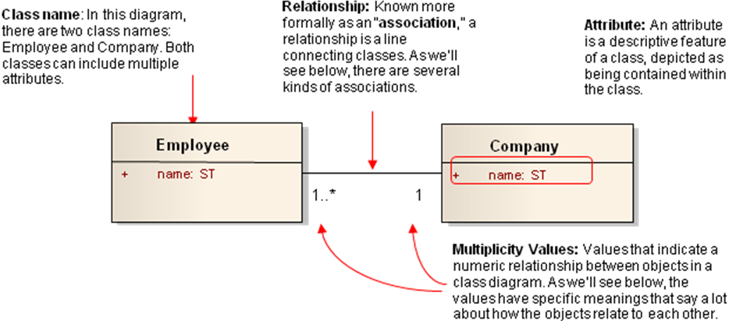
Figure A1: High level overview of the parts of a class diagram

This diagram is communicating several things. First, it’s saying that both instances of the classes called Employee and Company have the attribute “name.” Furthermore, the diagram says there is certain kind of relationship between Employee and Company. You’ll notice a few other things like the numbers of the multiplicity values and the letters “ST” but don’t worry about them now. We’ll address them below.

Attribute names and data types
Let’s look more specifically at the chief characteristics of a class’s attributes, since this will help immensely in being able to read the BRIDG Model. As explained above, every class has a class name, and each class has one or more attributes. Most attributes have at least three parts: one, an attribute name; two, an attribute type; and three, a visibility mark, represented by a sign such as the plus (+) or minus (-) sign in front of the attribute name. The plus sign indicates that the attribute is “public,” and the minus sign indicates that it is “private.” The plus and minus sign are values for the scope (also called visibility) property. This property allows classes or attributes to selectively be displayed by class or diagram. Other marks can be used to indicate whether the attribute is “protected” or “package,” but the BRIDG UML model doesn’t use them.

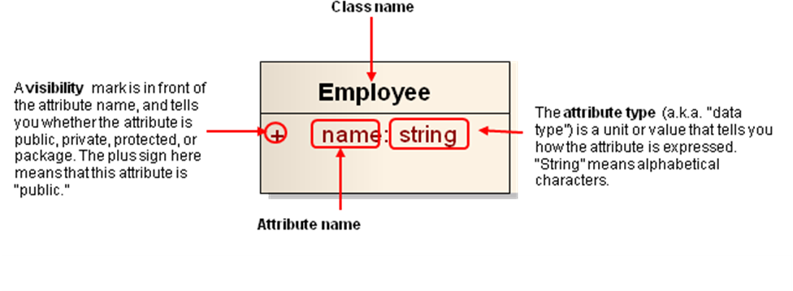
Figure A2: Anatomy of a UML class

What does this particular class tell us? First, the plus sign tells us the “name” attribute is public. In fact, in the BRIDG, all elements are public, so the only visibility indicator you will encounter in the BRIDG is the plus (+) sign.

What does the attribute type “ST” mean, though? “ST”, which stands for “string”, in particular means that the name attribute must be represented as a set of alphanumeric characters. For example, an employee’s name could be “Julia Roberts”. Of course, there can be other attribute types such as “integer” (i.e., numbers only) and “Boolean” (i.e., true or false), as shown in the next example. Together, this group of attributes makes up what is called an “attribute list” for a class.

To apply these concepts, let’s look at a specific example of a class from the BRIDG Model. The class we will examine is the Study class.

Example of an attribute list of a class from the BRIDG
The Study class, shown in Figure A3, is one of the most important classes in the BRIDG Model. Let’s use our newly-gained knowledge of attributes to interpret what it says.

First, notice that each attribute has a plus sign next to it, meaning that all the attributes are “public.” Second, take a look at the attribute names. Many of them, such as accrualReportingMethodCode and studySubjectTypeCode, are pretty self-explanatory to people working in clinical research. The former is a coded value used to represent the format on how subject accrual data should be reported back to the study sponsor (e.g., as “complete” or “abbreviated”). The latter is a coded value used to represent the target entity of the study of investigation. For example, in a clinical study, the subject type would be “human,” but in other studies it could be animals such as “rats” or “mice.”

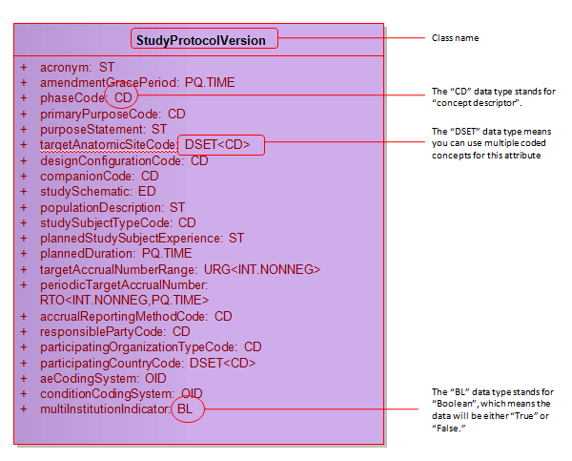
Figure A3: Attributes of the Study class

Next, notice that each attribute has a corresponding attribute type, or data type. These types are all based on HL7/ISO data type specification. Each type indicates what kind of data is used to represent the attribute. For example, look at the first attribute in the list, multiInstitutionIndicator. You can imagine that this attribute is designed to answer the question, “Does this protocol accept healthy volunteers?” The answer must be either yes or no. Hence, it makes sense that its data type is BL, or Boolean, which means the data can be expressed as either “true” or “false.”

Different types of associations between classes in a UML diagram
The next important UML concept to know in order to read and understand BRIDG is the concept of relationships or associations. There are multiple types of associations between classes: inheritance, composition, and aggregation. While the names sound pretty technical, these are relatively simple ideas, each of which we’ll cover below.

Associations
An association means that both classes are aware of each other and their relationship. That is, both classes are “known” to each other. An association is indicated by a solid line between the classes. At either end of the class is a multiplicity value. For example, in the diagram below, the multiplicity value of 0..* next to the StudySite class means that when an instance of HealthcareFacility exists, it can have zero or more instances of a StudySite associated with it. Taken in the context of clinical research, this makes sense. After all, even when a HealthcareFacility exists, it could take time for the first study site to be identified. Moreover, the number of study sites associated with a healthcare facility should be left open-ended in order for a variable number of study sites to be identified.
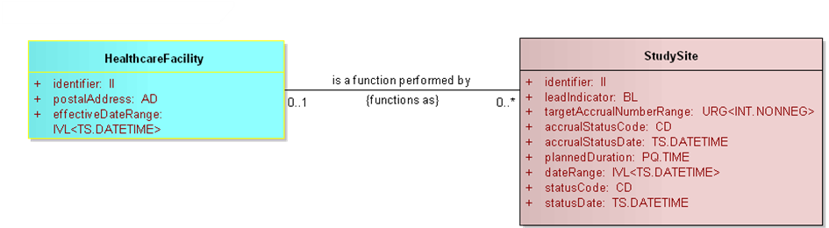
Figure A4: Example of an association between two classes

Conversely, the multiplicity value of 0..1 next to the HealthcareFacility class means that when an instance of StudySite exists, it can have zero or one HealthcareFacilties associated with it. This also makes sense in context, because in a particular study, a study site is not assigned to more than one healthcare facility.

There are, of course, a variety of ways you can designate multiplicity values. A few examples are shown in the table below.

Multiplicity Value | Meaning
0..1 | Zero or one
1 | One only
0..* | Zero or more
* | Zero or more
1..* | One or more
2 | Two only
0..6 | Zero to six
5..15 | Five to fifteen

Specialization
Specialization is the ability of a class to receive or acquire the same exact attributes and functionality of another class, in addition to its own set of unique attributes and functionalities. This relationship is expressed in terms of “parent” and “child.” Take an example from real life: a child may inherit a parent’s brown hair. However, that same child may be the only one in the family to have blue eyes. Likewise in UML, a class may inherit attributes from a parent class but still retain unique attributes of its own.

In the context of UML, specialization is shown by drawing a solid line from the child to the parent class. At the end of the solid line is a closed, unfilled triangle (or arrowhead) pointing to the parent class. The child class also includes a listing of the parent class’s elements under an italicized heading.

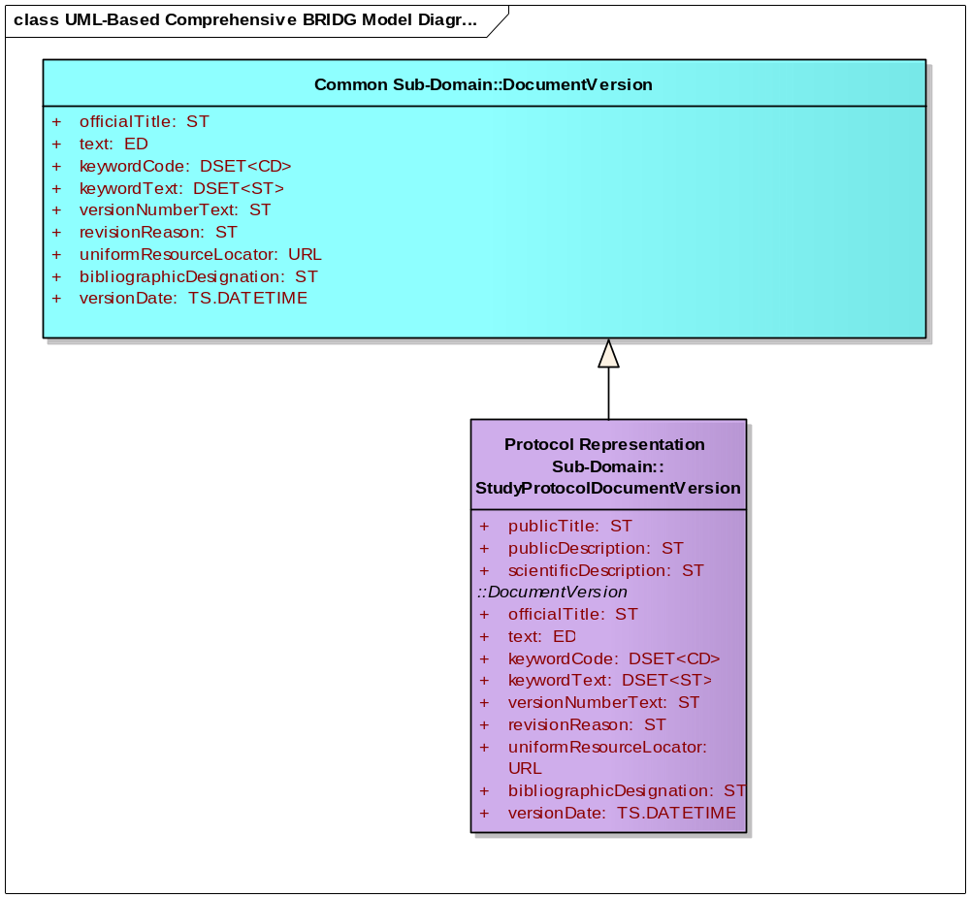
Parent Class
Child Class
Specialization is shown by a solid line with an unfilled triangle pointing to the parent class.
Unique Attributes
Attributes inherited from the DocumentVersion class
Italicized heading indicates which class the attributes are inherited from
Figure A5: Example of specialization within BRIDG

As an example from the BRIDG Model, the StudyProtocolDocumentVersion class is a “child” to the DocumentVersion class. This means that, in addition to its unique attributes, the StudyProtocolDocumentVersion class receives or acquires the full set of attributes from the DocumentVersion class.

Now consider this relationship in context. “Document” is a generic term that could encompass many kinds of documents. Indeed, all clinical research involves regulatory processes that require the submission of multiple documents from the Applicant to the Regulatory Authority. The DocumentVersion class is, therefore, an abstract concept that contains attributes common to all types of documents, such as officialTitle, versionNumberText, etc., which should be present no matter what type of document is being developed, whether an adverse event report or autopsy report. A StudyProtocolDocumentVersion is a specific type of document that falls under the broader category of document. It thus makes sense for the StudyProtocolDocumentVersion class to inherit attributes from the DocumentVersion class.

Aggregation
The association known as aggregation is a type of association that shows that a parent class is composed of or contains child classes. It shows how more complex parent classes (aggregates) are built from a collection of simpler child classes (component parts; e.g. a car from wheels, tires, motor and so on). If the parent class is removed, the child class is not. This relationship is represented by a solid line with an empty diamond shape on the parent class’s association end.

In the diagram below (Figure A6), one or more BiologicEntityGroups is composed of zero or more BiologicEntityGroups. If BiologicEntityGroup is removed, BiologicEntity remains in the model.

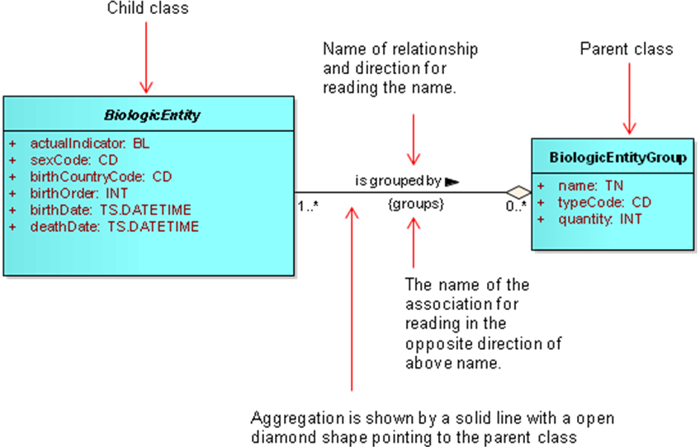
Figure A6: Example of an Aggregation relationship in BRIDG

Composite Aggregation
The association known as composite aggregation shows a “parts to the whole” relationship between a parent and a child class. In this relationship, the child class is part of the parent class, which is a stronger relationship than the aggregation relationship discussed above. Additionally, the child class’s existence depends on the parent class’s existence. If the parent class is removed, the child class is automatically removed as well. This relationship is represented by a solid line with a filled diamond shape on the parent class’s association end.

In the diagram below, one or more Submission classes are part of the RegulatoryApplication class. There is only one RegulatoryApplication, and if it is removed, then Submission is removed as well.

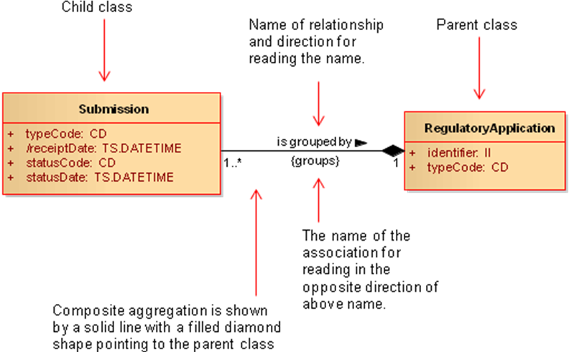
Figure A6: Example of an Aggregation relationship in BRIDG

As the name implies, the RegulatoryApplication class refers to a collection of submissions that are grouped together for regulatory purposes, and are usually specific to a particular device, food, or feed additive or biopharmaceutical substance. The Submission class refers to any compilation of the contents of one or more submission units that supports a specific regulatory purpose or decision. It therefore makes sense that there is an aggregation relationship between these two classes, since a regulatory application in the world of clinical research may consist of multiple submissions.

End of Document

